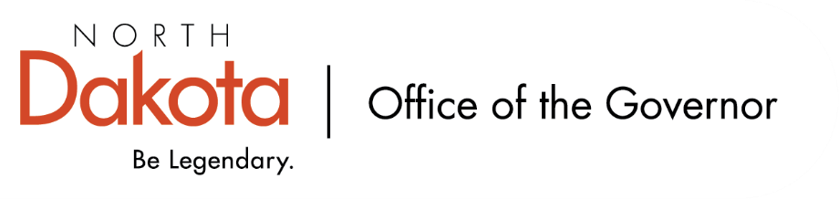

North Dakota Children’s Cabinet
Tuesday, December 16, 2025
4:00 p.m., Central Time
Microsoft Teams

Members in Attendance:
- Lieutenant Governor Michelle Strinden
- Senator Michelle Axtman
- Justice Lisa McEvers
- Commissioner Pat Traynor
- Superintendent Levi Bachmeier
- Senator Kathy Hogan
- Representative Brandy Pyle
- Ms. Kimberly Jacobson
- Ms. Janell Regimbal
- Mr. Russ Riehl
- Ms. Veronica Zietz

Members Absent:
- Representative Jayme Davis
- Ms. Daniell Breland
- Mr. Shawn Huss

Other Attendees:
- Ms. Missi Baranko
- Mr. Jason Callahan
- Ms. Kelly Eppley
- Ms. Cathy Ferderer
- Ms. Michelle Fockler
- Ms. Pritha Gopalan
- Ms. Maria Neset
- Ms. Mary Christy

Ms. Zietz moved to approve the North Dakota Children’s Cabinet minutes from November 18, 2025. Representative Pyle seconded. The motion to approve the minutes carried.

Early Childhood Subcommittee Share Out
The Hunt Institute (Ms. Eppley, Ms. Fockler, and Ms. Gopalan) will be working with the Subcommittee as an external partner to provide technical support, to help on the data front / help with reporting, best practices, and moving the Subcommittee forward with strategic goals. The Hunt Institute team has supported task force work back in 2024 and excited to be back in an early childhood context.

Next Meeting – Wednesday, December 17 from 11 – 11:30 am; Wednesday, January 14, 2026 from 4 – 5 pm.

HB1556 Subcommittee Share Out
Looking to have eight regional meetings to look at issues with children / adolescents with significant behavioral health needs. Region 3 (Devils Lake) and Region 4 (Grand Forks) will be held this month; will try to hold three in January and three in February. Trying to keep the group to 8-10, but there has been excitement about the meetings and individuals reaching out wanting to know more and engage.

Legislative Council will be researching Children Services Coordinating Committees (CSCC) history, programs, and outcomes as a reference document to have moving forward; will have a policy analyst to help as well.

There are a number of task forces – diversion task force, juvenile justice K-12 truancy, level D – discussion on if it may be worth thinking about how we capture the information and results from their work and how it impacts the work being done in the Children’s Cabinet and subcommittees.

Next meeting – Friday, January 9, 2026 from 8 – 9:30 am.

Strategic Planning Subcommittee Share Out
Will be working on receiving editable version of PDF Draft from The Forum for Youth Initiative. Will want to include edit re: statutory reporting from entities to the Children’s Cabinet. Lt. Governor Strinden motion to approve Children’s Cabinet Ops Manual with minor adjustments re: statutory reporting and photo; Mr. Riehl Russ seconded. Motion approved.

Discussion regarding child well-being indicators. Indicators will fall into one of five areas:
- Economic stability (children living in poverty (0-17), unemployment rate of parents, homeless youth, opportunity youth)
- Family and community (access to quality early childhood, chronic absenteeism, extracurricular involvement, family economic stability)
- Education (kindergarten entry readiness, 3rd grade reading proficiency, choice-ready graduates, post-secondary enrollment)
- Health and safety (screen time, school discipline, mental health, access to school-based behavioral health services)
- The early years (infant mortality rate, WIC participation, childcare providers, quality early childhood education).
Will provide data in these five areas to help policy makers and practitioners. Scorecard examples discussed more for how best to design, what graphics are easiest to tell North Dakota’s story, will be easy to understand, trends over time. Consensus that the domains and indicators are moving in the right direction; subcommittee will work to finalize.

Next meeting –Tuesday, December 23 from 4 – 5 pm.

Closing remarks
- In-person retreat – Monday, March 9, 2026 in Fargo
- Next meeting – Tuesday, January 20, 2026 from 3:45 – 5 pm

