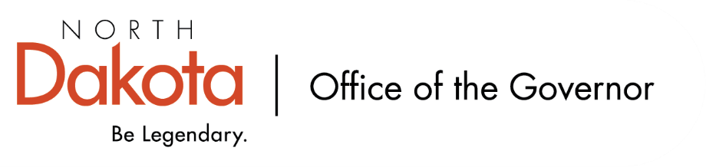

North Dakota Children’s Cabinet – Early Childhood Subcommittee
Wednesday, February 11, 2025
2 pm, Central Time
Microsoft Teams

Members in Attendance:
- Lieutenant Governor Michelle Strinden
- Senator Michelle Axtman
- Deputy Commissioner Emily O’Brien, North Dakota Department of Health and Human Services on behalf of Commissioner Pat Traynor
- Ms. Amanda Peterson, North Dakota Department of Public Instruction on behalf of Superintendent Levi Bachmeier
- Ms. Keely Ihry, South East Education Cooperative

Members Absent:
- Representative Jayme Davis

Other Attendees:
- Ms. Kelly Eppley, The Hunt Institute
- Ms. Michelle Fockler, The Hunt Institute
- Ms. Pritha Gopalan, The Hunt Institute
- Ms. Missi Baranko
- Mr. Jason Callahan
- Ms. Mary Christy
- Ms. Allison Mahoney
- Ms. Julie Ritter
- Ms. Shonda Wild

Ms. Ihry moved to approve the minutes from the North Dakota Children’s Cabinet Early Childhood Subcommittee meeting on January 14, 2026. Deputy Commissioner O’Brien seconded. Motion approved.

Stakeholder Interviews and Scope (going beyond Best in Class) - updates
Discussion surrounding The Hunt Institute’s stakeholder interviews have focused on key stakeholders in early education (legislators, agency, data), practitioners, and parents. Have pivoted to include looking at Early Head Start and childcare in addition to Best in Class as well as rural and urban communities. Idea is to identify best practices across all settings.

Discussion on The Hunt Institute’s approach in unpacking school readiness. Will want to identify and measure different aspects of school readiness with a focus on the importance of high-quality early care and education.

The Hunt Institute will also be looking into data including early learning standards, QRIS, ECIDS, additional frameworks and measures – what is currently out there, what are working models, what can be improved?

Shared discussion on resources throughout the state that focus on employee programs with onsite opportunities for childcare and how they fall into existing opportunities for existing programs through the state; ability to tie into the Regional Health Transformation Program; hospitals / critical access hospitals; how sustainable are varying programs / services (non-profits v for profit).

Will take all the data and feedback to help the subcommittee and Children’s Cabinet create potential policy considerations. If anyone has additional data sets, reports, resources – please send to The Hunt Team or Ms. Mary Christy (machristy@nd.gov).

Subcommittee Check In and Adjourn
- Next Children’s Cabinet Early Childhood Subcommittee meeting: Wednesday, March 11, 2026 @ 2-3 pm on Microsoft Teams

