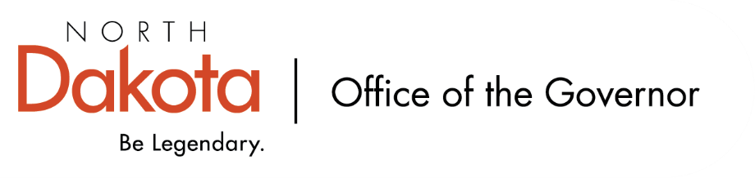

North Dakota Children’s Cabinet – HB1556 Subcommittee
Friday, February 13, 2026
8 – 9:30 am, Central Time
Microsoft Teams

Members in Attendance:
- Senator Kathy Hogan
- Director Colby Braun, ND DOCR
- Ms. Rhonda Allery, Mountain Lakes Human Service Zone Director
- Dr. Dan Cramer, NDHHS Behavioral Health Direct Services
- Ms. Kari Davis, ND DOCR, Juvenile Services Program Manager
- Ms. Cathy Federer, Director of Juvenile and Family Services, ND Court System
- Mr. Shawn Huss, Wilmac Special Education Unit
- Ms. Nicole Leitner, Director of Juvenile Court Service, Unit 2
- Ms. Mary McCarvel-O'Connor, NDDPI
- Ms. Pamela Sagness, NDHHS Behavioral Health
- Ms. Veronica Zietz, Protection and Advocacy Project

Members Absent:
- Ms. Janell Regimbal, Insight to Solutions

Other Attendees:
- Ms. Missi Baranko
- Mr. Jason Callahan
- Ms. Mary Christy
- Ms. Lynn Flieth
- Mr. Tim Gienger
- Ms. Maria Neset
- Mr. Luke Schaefer
- Ms. Michelle Woodcock

Roll Call / Approval of Agenda
Ms. Leitner moved to approve the minutes from the North Dakota Children’s Cabinet HB1556 Subcommittee on January 9, 2026; Director Braun seconded. Motion approved.

Overview of Children’s Cabinet status and activities
Will be renaming the HB1556 Subcommittee to Youth with Complex Needs Subcommittee. Members agreed. Will take to the full Children’s Cabinet next week before changing the name.

Regional Meetings Update
Briefly reviewed the slides that were presented at each of the regional meetings. The same agenda was used for each regional meeting with minimal updates to the slides; the meat of the meetings was the same at each.

Strong sense of those who are local, involved / working with kids did not feel as though they have a voice in policy development and framing the issues; guiding values evolved to include locally driven, state supported, shared responsibility. Momentum built in each region to continue to meet, independent of the subcommittee, to continue the conversation; one to two people from each regional meeting have volunteered to serve as facilitators.

Discussion among those who participated in the regional meetings. Appreciation for Senator Hogan and Mr. Callahan for leading the effort; they were well managed and thoughtful, attendance among the different groups / organizations was welcomed, discussions among each group were beneficial and eye opening throughout issues presented (gaps, strengths, themes).

During the regional meetings, new initiatives were presented throughout the regions that are aligned with the work being focused on. Research is being done on who the parallel groups are, what they are doing, and how we can work together more effectively. Hoping to take the meeting notes and build a system of support for local leadership. If anyone is aware of parallel groups, additional data please let Mr. Callahan, Ms. Neset, or Ms. Christy know.

Next Steps and Adjourn
- Next meeting scheduled for Friday, March 13, 2026 at 8 am via Teams

