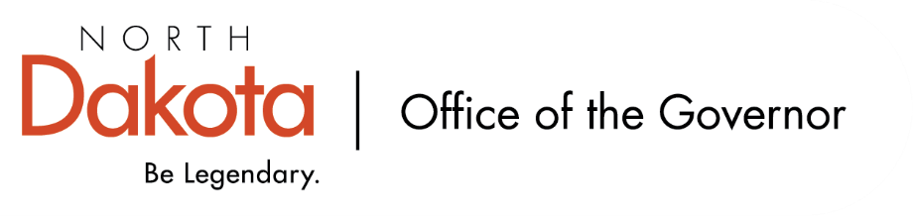

North Dakota Children’s Cabinet
Tuesday, February 17, 2025
3:45 p.m., Central Time
Microsoft Teams

Members in Attendance:
- Lieutenant Governor Michelle Strinden
- Senator Michelle Axtman
- Commissioner Pat Traynor
- Superintendent Levi Bachmeier
- Senator Kathy Hogan
- Representative Brandy Pyle
- Mr. Shawn Huss
- Ms. Janell Regimbal
- Mr. Russ Riehl
- Ms. Veronica Zietz
- Representative Jayme Davis
- Chief Justice Lisa McEvers
- Ms. Kimberly Jacobson
- Ms. Daniell Breland

Members Absent:

Other Attendees:
- First Lady Kjersti Armstrong
- Ms. Missi Baranko
- Mr. Jason Callahan
- Ms. Kelly Eppley
- Ms. Cathy Ferderer
- Ms. Michelle Fockler
- Ms. Pritha Gopalan
- Ms. Maria Neset
- Ms. Mary Christy
- Ms. Amanda Peterson

Without a quorum at the start of the meeting, the Children’s Cabinet cannot approve minutes. Will look to approve December and February minutes at the next meeting in March.

Early Childhood Subcommittee Share Out
Will be expanding reach beyond Best in Class to include childcare and Early / Head Start. The Hunt Institute Team will be conducting interviews with stakeholders (practitioners, parent leaders, parents, state agencies and organizations), site visits (both urban, rural, and tribal), and literature / document review to help look at framework for school readiness to include actionable policy considerations.

Next Meeting – Wednesday, March 11, 2026 from 2 – 3 pm

HB1556 Subcommittee Share Out
HB1556 will be updating their name to Youth With Complex Unmet Needs that more accurately reflect the work they are doing.

Held regional meetings in all 8 regions over the last two and a half months. Significant differences in services throughout the regions and majority of attendees hadn’t met before the meetings – two big takeaways. All 8 regions will be continuing to meet, independent of the subcommittee, to keep the conversations moving forward. Summaries of each meeting have been completed and will be looking to pull together themes of strengths, gaps, and opportunities; will focus on empowering our local stakeholders.

Next meeting – Friday, March 13, 2026 from 8 – 9:30 am.

Strategic Planning Subcommittee Share Out
Mr. Callahan has been coordinating stakeholder interviews among state and regional leaders, agencies, and organizations to help determine data validation and the work being done on establishing indicators to help share child wellbeing in North Dakota; five domains resonated with stakeholders. Dashboard will be a starting point that will continue to get refined as the work moves forward.

North Dakota was accepted into the current NGA Data Dashboard cohort.

Rural Health Transformation Program (RHTP) – Commissioner Traynor
Overall goal is to have the healthiest citizens in the nation. Interested in helping to reboot and redefine what our north star is in terms of programs and services; how can we make our partnerships across the state more meaningful and productive?

RHTP will focus on four areas: strengthen and stabilize rural health workforce, bring high-quality health care closer to home, make North Dakota healthy again, and connect tech, data and providers for a stronger North Dakota.

There are deadlines as to when the funds must be spent each year, of the five years of the RHTP, and how / where the funds can be spent. Funds are meant to go towards sustainable projects and / or services. For example, new construction and funding ongoing operations is unallowable, but what may be allowable includes: facilities, childcare, school-based services (such as a wellness coordinator).

Looking at building a team of consultants to help North Dakota maximize opportunities to plan, implement, and continue serving in the healthcare space; electronic health records and data; how do we recruit, retain, and grow our own workforce; prevention.

Anticipate opportunities to apply for funding to be available in March; NDHHS website is the best place to look for updates and to sign up to be included on their newsletter list.

Closing remarks
- In-person retreat – Monday, March 9, 2026 in Fargo
- Next meeting – Tuesday, March 17, 2026 from 3:45 – 5 pm

