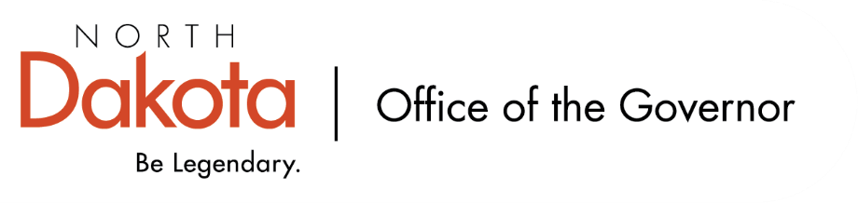

North Dakota Children’s Cabinet
Monday, March 9, 2025
9:00 am, Central Time
Governor’s Office – 3435 56th Street South, Fargo, ND

Members in Attendance:
- Lieutenant Governor Michelle Strinden
- Senator Michelle Axtman
- Commissioner Pat Traynor
- Superintendent Levi Bachmeier
- Senator Kathy Hogan
- Representative Brandy Pyle
- Mr. Shawn Huss
- Ms. Janell Regimbal
- Mr. Russ Riehl
- Ms. Veronica Zietz
- Chief Justice Lisa McEvers
- Ms. Kimberly Jacobson

Members Absent:
- Representative Jayme Davis
- Ms. Daniell Breland

Other Attendees:
- Mr. Jason Callahan
- Mr. Tim Eissinger
- Ms. Michelle Fockler
- Ms. Pritha Gopalan
- Ms. Keely Ihry
- Ms. Maria Neset
- Ms. Mary Christy

Commissioner Traynor moved to approve the North Dakota Children’s Cabinet minutes from December 16, 2025 and February 17, 2026. Ms. Zietz seconded. The motion to approve carried.

Opening Remarks and Overview of Work Sessions
Reviewed Children’s Cabinet values, mission, and vision as we headed into a full day of meeting as subcommittees and full cabinet.

North Dakota was accepted into the current NGA Data Dashboard cohort; opportunity to help further Goal 2 – define, measure, and report out on the status of child well-being in North Dakota. Seven states are included in the cohort.

Discussion around holding the cabinet accountable to the work we are doing / implementing the work we are doing; will be including this in some form in the Strategic Plan.

Feedback on the five domains (economic; family and community; education; health and safety; the early years) and indicators has been well received. Discussion on if / where adult education would be included?

Youth-Related Work Sessions
There are a number of working groups, studies, etc. that are looking at issues that connect to the work of the Children’s Cabinet. A request was made to gather information relating to their work with the potential to coordinate efforts as it relates to solutions and priorities.

Recommended to members to refer additional working groups, studies, etc. they are aware of to Ms. Neset and Ms. Christy for follow-up.

Early Childhood Subcommittee Share Out
Stakeholder feedback sessions with The Hunt Institute have been well received and will be continuing. The subcommittee reviewed six emerging policy recommendations that includes: building a shared understanding of school readiness, strengthen the mixed delivery system supporting 4-year old programs, ensuring children are ready for schools and schools are ready for children, provide intentional and collaborative opportunities for preschool / kindergarten / first grade teachers, strengthen the Early Childhood Integrated Data Systems and build connections to the K-12 system, and leveraging opportunities for collaboration among statewide child and family-focused initiatives.

Heard from two external experts on school readiness that included: Dr. Steve Barnett, Founder and Senior Co-Director of the National Institute for Early Education Research and Dr. Annemarie Hindman, Professor, UNC School of Education.

Discussion around the idea of a readiness checklist for our pre-K youth, educator support and engagement essential. Want to meet educators where they are at and not create additional, duplicative efforts in helping to see where our youth are at before they begin kindergarten.

Youth with Complex, Unmet Needs Subcommittee Share Out
Group discussed the APHSA definition and will work to simplify it for the work the subcommittee is doing; 12 states are also working on this issue.

Throughout December – February, eight regional meetings were held (one in each region) with local leaders, school officials, agency representatives, and parents. Will continue to work through strengths and challenges from across the state and working on strategic priority solutions and policy recommendations. One common theme emerged as a guiding value: state supported, locally driven, shared responsibility. Intention is to continue to build relationships throughout the regions as they continue to meet on their own and keep an open line of communication for any questions or ideas they have.

Closing remarks
- Next meeting – Tuesday, March 17, 2026 from 3:45 – 5 pm

