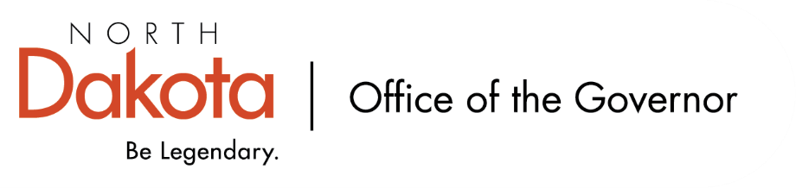

North Dakota Children’s Cabinet
Tuesday, March 17, 2025
3:45 pm, Central Time
Microsoft Teams

Members in Attendance:
- Lieutenant Governor Michelle Strinden
- Senator Michelle Axtman
- Mr. Tim Eissinger on behalf of Commissioner Pat Traynor
- Senator Kathy Hogan
- Representative Brandy Pyle
- Ms. Veronica Zietz
- Chief Justice Lisa McEvers
- Ms. Kimberly Jacobson
- Ms. Shanda Cool
- Ms. Daniell Breland
- Mr. Shawn Huss
- Superintendent Levi Bachmeier
- Representative Jayme Davis

Members Absent:
- Ms. Janell Regimbal
- Mr. Russ Riehl

Other Attendees:
- Ms. Missy Baranko
- Mr. Jason Callahan
- Ms. Kelly Eppley
- Ms. Cathy Ferderer
- Ms. Michelle Fockler
- Ms. Pritha Gopalan
- Ms. Keely Ihry
- Ms. Maria Neset
- Ms. Amanda Peterson
- Ms. Heather Traynor
- Ms. Mary Christy

Ms. Zietz moved to approve the North Dakota Children’s Cabinet minutes from March 9, 2026. Representative Pyle seconded. The motion to approve carried.

Subcommittee list shared; asked members to please let Senator Axtman, Ms. Neset, and Ms. Christy know if they would prefer to move to a different subcommittee.

Ms. Cool introduced herself; she is the parent member of the Children’s Cabinet.

Early Childhood Site Visits Debrief
YMCA quality program that highlighted their services including Best in Class (two classrooms); also provide infant and after school care. The challenges include changes with childcare assistance. Recommendation that Best in Class should start at age 3 (currently starts at age 4).

Peace Academy was a beautiful facility with intentionality built into the physical space plus what they teach through play. They have a parent education program that is virtual and open to parents, others in the childcare space – would love to engage more people across the state.

Mayville State University Child Development Program has an early head start, head start, and childcare; good model for mixed delivery. Utilizing high care throughout all the rooms and with each group of children – could not tell who was in head start, early head start, childcare.

Play-based learning was evident across all the sites. Emphasis on parent engagement, education, and outreach. Importance of coaching (with Best in Class) to help with success of teachers and practices.

Youth with Complex, Unmet Needs Site Visits Debrief
Explorer Academy was child and family focused, building itself is well thought out and intentional to encourage and support the youth they serve (K-8). Parents commented they knew when their children were there, they were safe. They work with the school district and homeschools to help with referrals, continue to make modifications to serve their students, and make great use of their resources.

Dakota Boys and Girls Ranch help to serve students through day school in the higher grades. Working to provide stability and support while they are there and as they get ready to transition back to their school / homeschool throughout the state (not necessarily here in Fargo). Celebrate every win, but there was a heaviness to the visit in thinking about how / why the youth are there and how best to transition back home, especially when their community does not have services to help like Dakota boys and Girls Ranch. Transportation and admissions can be a challenge.

Retreat Debrief
Appreciated the opportunity to be in person. Idea of moving the retreat around the state to different zones with the opportunity to do more site visits. Tours were instrumental in connecting with the work the Children’s Cabinet is focusing on. Recognizing and seeing the programs that are working well was inspiring.

Annual report due August 1, 2026 to include what we have done – does not need to include subcommittee work but can consider including. Will be looking to hold a retreat before / around this time.

Children Service Coordinating Committee Materials
Began in 1989 (through 2008) was similar to the Children’s Cabinet with one coordinating committee in each of the eight regions and four tribal areas. Option for us to consider looking at as we move forward in building cross-systems collaboration.

Each of the regions that held meetings between December – February are continuing to meet. Asking that they let Senator Hogan know so we are able to be engaged through agenda’s, minutes, and helping to be a line from those on the ground to the Children’s Cabinet.

Closing remarks
- Next meeting – Tuesday, April 21, 2026 from 3:45 – 5 pm

