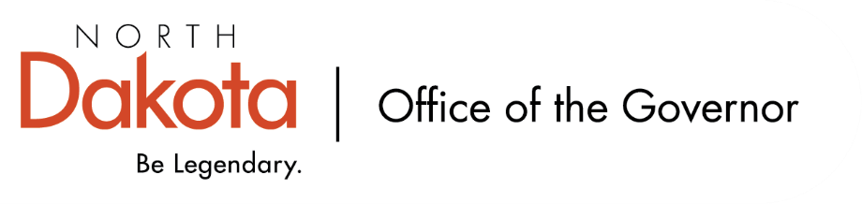

North Dakota Children’s Cabinet – Youth with Complex, Unmet Needs Subcommittee
Friday, April 10, 2026
8 – 9:30 am, Central Time
Microsoft Teams

Members in Attendance:
- Senator Kathy Hogan
- North Dakota Supreme Court Chief Justice Lisa McEvers
- Ms. Rhonda Allery, Mountain Lakes Human Service Zone Director
- Director Colby Braun, ND DOCR
- Ms. Daniell Breland, Tribal Relations Representative, Turtle Mountain Director of Child Welfare and Family Services
- Ms. Shanda Cool, Parent Representative
- Dr. Dan Cramer, NDHHS Behavioral Health Direct Services
- Ms. Kari Davis, ND DOCR, Juvenile Services Program Manager
- Mr. Tim Eissinger, Executive Director NDHHS
- Ms. Cathy Federer, Director of Juvenile and Family Services, ND Court System
- Mr. Shawn Huss, Wilmac Special Education Unit
- Ms. Nicole Leitner, Director of Juvenile Court Service, Unit 2
- Ms. Mary McCarvel-O'Connor, NDDPI
- Ms. Janell Regimbal, Insight to Solutions
- Mr. Russ Riehl, Bismarck Public Schools
- Ms. Pamela Sagness, NDHHS Behavioral Health
- Ms. Veronica Zietz, Protection and Advocacy Project

Members Absent:

Other Attendees:
- Mr. Aaron Benson
- Mr. Jason Callahan
- Ms. Mary Christy
- Ms. Lynn Flieth
- Mr. Tim Gienger
- Ms. Allison Mahoney
- Ms. Maria Neset
- Mr. Luke Schaefer
- Ms. Michelle Woodcock

Roll Call / Approval of Agenda
Director Braun moved to approve the minutes from the North Dakota Children’s Cabinet HB1556 Subcommittee on February 13, 2026; Ms. Leitner seconded. Motion approved.

Overview of Children’s Cabinet status and activities
Brief overview of March 9th Children’s Cabinet in-person retreat including this subcommittee narrowing down priorities and action steps as we move forward. On March 10th, a handful of members did site visits in the area to include Mayville State University touring Head Start / early childhood services and Explorer Academy in Fargo.

Reviewed guiding values that came from the regional meetings, top priorities, and draft policy recommendations that are being looked at how to take from an idea into action. Discussion around Systems of Care policy recommendations – Reservation(s) standpoint, rural access, budget constraints, shared resources / collaboration / efficiencies.

APHSA definition of Complex, Unmet Needs reviewed. Resonated at the eight regional meetings, but feedback was it is lengthy. Considering condensing it to “young people who present with challenges that exceed the capacity of any single service provider or traditional placement setting” for the subcommittee / Children’s Cabinet work. Ms. Regimbal, Ms. Cool, Dr. Cramer expressed interest in helping to refine / condense the definition.

Discussion of Continuation for Regional Meeting Structures
Discussion on continuing to be involved in regional meetings; what is missing, what can we help with, how do we foster a feedback loop. Many of the regions have already held a second meeting independent of the subcommittee. To provide freedom to meet and visit about their own work, but also guidance on feedback that would be helpful to policy makers, Senator Hogan and Mr. Callahan will be reconnecting with the regional facilitators.

Other Related Initiatives - Youth Related Entities Studies
Review of youth related entities’ studies spreadsheet; asked for the subcommittee to let Senator Hogan, Ms. Neset, and Mr. Callahan know of any additional groups.

Update on Diversion Task Force/CHINs – Ms. Lynn Flieth
CHINS = children in need of services; roughly ages 10 – 17; exhibiting negative behaviors that are NOT criminal in nature such as truancy, using / possessing tobacco / vaping, running away, disobeying lawful and reasonable commands of their parent or guardian. In 2021 the law changed to promote a lighter touch approach with the intention of leading to a more positive outcome and less likelihood to appear in the adult criminal justice system.

North Dakota HB1012 established one time funding, through the human services finance fund, for a diversion task force and a report to the Children’s Cabinet and legislative management. Task force has been meeting monthly; having good conversations, some have been hard, but are necessary to move the work forward with a focus on providing access, not barriers.

Next Steps and Adjourn
- Next meeting scheduled for Friday, May 8, 2026 at 8 am via Teams

