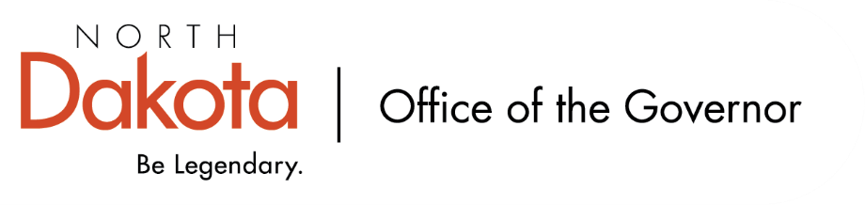

North Dakota Children’s Cabinet – Early Childhood Subcommittee
Monday, April 13, 2025
1 pm, Central Time
Microsoft Teams

Members in Attendance:
- Lieutenant Governor Michelle Strinden
- Senator Michelle Axtman
- Mr. Tim Eissinger on behalf of Interim Commissioner Pat Traynor, North Dakota Department of Health and Human Services
- Ms. Keely Ihry, South East Education Cooperative
- Ms. Kim Jacobson, Agassiz Valley HSZ Director
- Representative Brandy Pyle

Members Absent:
- Superintendent Levi Bachmeier, North Dakota Department of Public Instruction
- Representative Jayme Davis
- Ms. Amanda Peterson, North Dakota Department of Public Instruction

Other Attendees:
- Ms. Kelly Eppley, The Hunt Institute
- Ms. Pritha Gopalan, The Hunt Institute
- Ms. Mary Christy
- Ms. Kay Larson
- Ms. Allison Mahoney
- Ms. Maria Neset
- Ms. Taylor Olsen
- Ms. Julie Ritter
- Ms. Shonda Wild

Representative Pyle moved to approve the minutes from the North Dakota Children’s Cabinet Early Childhood Subcommittee meeting on February 11, 2026. Ms. Ihry seconded. Motion approved.

School Readiness Presentation
Presentation from NDDPI / NDHHS regarding school readiness efforts. Much of the work began with NDDPI’s Comprehensive Literacy State Development (CLSD) grant that covers literacy from birth through grade 12 with a focus on oral language and literacy growth and development. In 2024, updated the “On the 5’s” program to Legendary Learners. Legendary Learners collaborated project funded through CLSD 2019 grant focusing on Building Literacy Skills storybook, scrapbook, and parent guide.

Legendary Learners, funded through CLSD 2024 grant, is awarded to elementary buildings encouraging schools and communities to work together to create a School Readiness Transition Plan for roles and expectations beyond birth to five efforts that can extend beyond the funding.

NDHHS has helped create / provide a school readiness guide for Legendary Learners, also has a landing page for parents and educators; opportunity for growth in resources and sharing to a broader network.

NDHHS received a Preschool Development Grant (PDG) in 2018 and renewal in 2022; federally funded, focused on maximizing parent and family engagement in birth to five system (one of five required components).

January 2025 survey went out with 105 responses received. Gearing up for Kindergarten or district created programs / approaches were most used in regard to on-site kindergarten transition programs. PDG renewal funds supported LEAs in developing kindergarten transition plans.

Kindergarten Sturdy Bridge opportunity from 2023-2024 through the US Department of Education; focus on strengthening transition for early childhood settings into kindergarten / early elementary grades. Local LEA is required as part of the program; state team worked with Grafton Public School and Mandan Little Learners to learn successes, challenges, and opportunities in looking at professional development, family engagement, cross-sector kindergarten transition, among other items. Was able to support 12 schools with this funding.

PDG also used to develop a podcast, training (incentives for trainings (Seeds of Learning, LETRS) and non-incentives trainings), and a Pyramid Model in ND. NDHHS contracted with Dr. Kelli Odden with Mayville State University to help facilitate and implement a coaching guide and community of practices for pyramid model coaches in ND. This model is used in early intervention, Head Start, Best in Class, and childcare.

Questions from the subcommittee regarding grants and programs that have come from them, data, resources.

Summary of Stakeholder Interviews and Findings
The Hunt Institute team is working to engage more parents; have engaged a good number of individuals, agencies, and organizations throughout the state both public and private.

Emerging themes discussed including that school readiness should be viewed through a holistic lens, parent involvement / awareness about programs, transitions of 4-year-old programs into K-1, and promising models are in place in the state that we can learn from.

K-1 survey has been launched; will be launching the four-year-old, Best in Class, and Head Start shortly.

Subcommittee Check In and Adjourn
- Next Children’s Cabinet Early Childhood Subcommittee meeting: Wednesday, May 13, 2026 @ 2-3 pm on Microsoft Teams

