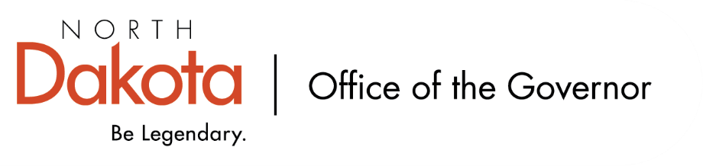

North Dakota Children’s Cabinet
Tuesday, April 21, 2025
3:45 pm, Central Time
Microsoft Teams

Members in Attendance:
- Commissioner Pat Traynor
- Ms. Amanda Peterson on behalf of Superintendent Levi Bachmeier
- Chief Justice Lisa McEvers
- Senator Kathy Hogan
- Ms. Kimberly Jacobson
- Ms. Janell Regimbal
- Mr. Russ Riehl

Members Absent:
- Lieutenant Governor Michelle Strinden
- Senator Michelle Axtman
- Representative Jayme Davis
- Representative Brandy Pyle
- Ms. Daniell Breland
- Ms. Shanda Cool
- Mr. Shawn Huss
- Ms. Veronica Zietz

Other Attendees:
- First Lady Kjersti Armstrong
- Mr. Jason Callahan
- Mr. Tim Eissinger
- Ms. Kelly Eppley
- Ms. Cathy Ferderer
- Ms. Pritha Gopalan
- Ms. Amanda Peterson
- Ms. Mary Christy

Quorum not met; will look to approve minutes from the North Dakota Children’s Cabinet March 17, 2026 meeting in May.

Early Childhood Subcommittee Share Out
Survey Updates / Responses – The Hunt Institute has completed leadership interviews, program / agency leaders and team interviews, and working on interviewing parents. Recently launched two surveys: K-1 looking at school readiness and four-year-old program looking at early childhood. Finding people have abandoned the survey when they get to the qualitative portion and believing this is due to individuals completing on their mobile devices and not as easy to provide answers; still able to use survey answers without the entire survey being completed.

School Readiness Activities by HHS/DPI – Share Out from Subcommittee Meeting. There are several programs throughout the state that we can pull from; working on learning about what is out there and how we can help define best practices or programs for our educators and parents. Question on funding sources for early childhood programs, sustainability of / for programs, etc. and how we drive action when there’s a need / want for programs.

Youth with Complex, Unmet Needs Subcommittee Share Out
Regional Meeting Update. Senator Hogan and Mr. Callahan had a meeting with the eight regional facilitators to circle back to the regional meetings that were held at the end of December 2025 – February 2026; these facilitators are also conducting meetings in each of their regions. Will continue to hold bi-monthly meetings with facilitators moving forward.

APHSA Definition Work Group is close to getting a more concise definition of what youth with complex, unmet needs look like for the work of the subcommittee and Children’s Cabinet. Briefly reviewed draft definition – thinking of adding a fifth descriptor to be environmental to include rural and urban needs. Feedback included one page summary definition was helpful as a common definition between systems / agencies / departments.

Youth Related Entities. As we have been learning or made aware of working groups / committees aligned with the work being done, we are asking them for reports or summaries of the work they are doing. We don’t want to duplicate but align as best we can with the work being done.

Data Dashboard Updates
National Governor’s Association Policy Academy on Data Dashboard work is moving forward. Discussion regarding the vision statement comprehensively capturing “youth thriving” for the purpose of the work being focused on, what are we missing, what can we update / improve on.

NGA has asked us to look at the pillars we shared and dig deeper into what we are trying to solve, elevating what we mean by “youth thriving”. We may be set on the pillars but continue to look at what is included with each pillar. Asking the Children’s Cabinet to help input any questions or comments into the ND Pillar Questions Brainstorm from NGA by the end of next week (May 1).

Closing remarks
- Next meeting – Tuesday, May 19, 2026 from 3:45 – 5 pm
- August In-Person Retreat – Ms. Christy will be sending out a survey with dates, Fargo or Bismarck, feedback

