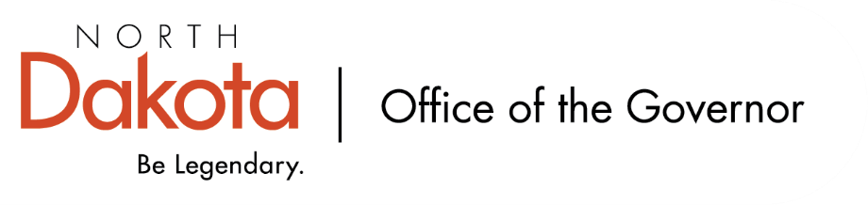

North Dakota Children’s Cabinet – Youth with Complex, Unmet Needs Subcommittee
Friday, May 8, 2026
8 – 9:30 am, Central Time
Microsoft Teams

Members in Attendance:
- Senator Kathy Hogan
- North Dakota Supreme Court Chief Justice Lisa McEvers
- Ms. Rhonda Allery, Mountain Lakes Human Service Zone Director
- Director Colby Braun, ND DOCR
- Ms. Daniell Breland, Tribal Relations Representative, Turtle Mountain Director of Child Welfare and Family Services
- Ms. Shanda Cool, Parent Representative
- Dr. Dan Cramer, NDHHS Behavioral Health Direct Services
- Ms. Kari Davis, ND DOCR, Juvenile Services Program Manager
- Mr. Tim Eissinger, Executive Director NDHHS
- Ms. Cathy Federer, Director of Juvenile and Family Services, ND Court System
- Mr. Shawn Huss, Wilmac Special Education Unit
- Ms. Janell Regimbal, Insight to Solutions
- Mr. Russ Riehl, Bismarck Public Schools
- Ms. Pamela Sagness, NDHHS Behavioral Health
- Ms. Veronica Zietz, Protection and Advocacy Project

Members Absent:
- Ms. Nicole Leitner, Director of Juvenile Court Service, Unit 2
- Ms. Mary McCarvel-O'Connor, NDDPI

Other Attendees:
- Mr. Aaron Benson
- Mr. Trent Barkus
- Mr. Jason Callahan
- Ms. Mary Christy
- Ms. Lynn Flieth
- Mr. Tim Gienger
- Mr. Luke Schaefer
- Ms. Michelle Woodcock
Roll Call / Approval of Agenda
Motion made to approve the minutes from the North Dakota Children’s Cabinet Youth with Complex, Unmet Needs Subcommittee on April 10, 2026; Senator Hogan seconded. Motion approved.

Overview of Children’s Cabinet status and activities
NGA Padlet Survey. NGA has asked us to look at the pillars we have been working on and dig deeper into what we are trying to solve, what we mean by “youth thriving.” Those involved with the data dashboard have already included their questions and asked the subcommittee if there are data points or questions that resonate with subcommittee members, please give them a thumbs up.

Regional Facilitator Meeting Update. Will be holding our next bi-monthly meeting with the regional facilitators in June; the first one was held in May.

Finalize Youth with Complex, Unmet Needs Definition
Reviewed and discussed proposed definition of Youth with Complex Needs; will continue to work on finalizing.

Regional Self-Assessment Tool and Implementation Process
Idea came from regional meetings that were held during December 2025 – February 2026. Intention is to not create more work, but to begin to see where there are gaps and how / where the state could lean in more. Hoping to finalize by the end of next week before sharing with the regional facilitators. Please send feedback to Senator Hogan and Mr. Callahan.

Level D Workgroup - Update
These are some of the most complex, special education needs. They are working to identify what the “best” looks like in North Dakota, percentage of special education population, and associated costs.

There are a number of groups doing studies that relate to the work of the subcommittee; trying to capture who they are and ask if anyone come across any groups to please share with Senator Hogan and Mr. Callahan.

Next Steps and Adjourn
- Senator Hogan and Mr. Callahan are putting together possible legislative solutions - please send any ideas you may have to them.
- Next meeting scheduled for Friday, June 12, 2026 at 8 am via Teams

