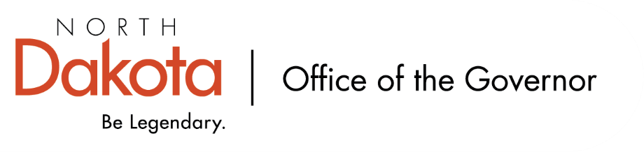

North Dakota Children’s Cabinet – Early Childhood Subcommittee
Thursday, May 14, 2026
11 am, Central Time
Microsoft Teams

Members in Attendance:
- Lieutenant Governor Michelle Strinden
- Senator Michelle Axtman
- Interim Commissioner Pat Traynor, North Dakota Department of Health and Human Services
- Representative Jayme Davis
- Mr. Tim Eissinger, NDHHS
- Ms. Keely Ihry, South East Education Cooperative
- Ms. Amanda Peterson on behalf of Superintendent Levi Bachmeier, North Dakota Department of Public Instruction

Members Absent:
- Ms. Kim Jacobson, Agassiz Valley HSZ Director
- Representative Brandy Pyle

Other Attendees:
- Ms. Missy Baranko
- Ms. Pritha Gopalan, The Hunt Institute
- Mr. Jason Callahan
- Ms. Mary Christy
- Ms. Kay Larson
- Mr. Jarvis Lundy, The Hunt Institute
- Ms. Maria Neset
- Ms. Julie Ritter
- Mr. Maureen Stover, The Hunt Institute
- Ms. Shonda Wild

Ms. Peterson moved to approve the minutes from the North Dakota Children’s Cabinet Early Childhood Subcommittee meeting on April 13, 2026. Representative Davis seconded. Motion approved.

Survey Updates – Early Childhood and K-1
More than 500 responses to the survey were received – teachers, principals, parent outreach, staff, childcare settings. Also conducted 81 stakeholder interviews.

School readiness includes a bi-directional view including families, 4-year-old programs, school districts, healthcare providers, and community organizations – all share a responsibility for children’s development. Dimensions of readiness include social-emotional skills, cognitive skills, language and literacy, numeracy and scientific reasoning, motor development, physical development, activities of daily life, and approaches to learning.

Review of survey responses as it relates to the individual readiness dimensions and importance among elementary educators and early educators, high alignment among both groups.

Elementary educators shared the level of school readiness needs improvement / average whereas early educators felt that level of school readiness was split more among needs improvement / average and good / excellent.

Review of systemic connections, professional development supporting school readiness, and parent education / education supporting school readiness all highlight areas of opportunity to increase connections, development, and education for both elementary educators and early educators.

Main themes from stakeholder interviews, as it relates to school readiness, included information-rich communities, hub-and-spoke models, practical parent education, multi-tiered systems of support, promising models for tribal and rural children, and comprehensive measurement framework. Working to show value of the programs currently operating in the state, but data / evaluation tools are limited as to how we show the investments are making an impact.

Policy considerations include building a shared understanding of school readiness, ensuring that schools are ready to meet children where they are, collaborate with other statewide family-facing initiatives, and strengthen the mixed delivery system of four-year-old programs.

Open Discussion / Q&A
Discussion on how we continue to measure results, develop a baseline, and the importance of being able to track if what we do makes an impact and what that impact is. Awareness of budgetary constraints.

Reminder that all of the above is a working document and this is the first go through with the subcommittee; will use the information as we move forward with possible budget or policy requests. Data is here to drive discussions as we continue to move forward.

Subcommittee Check In and Adjourn
- Next Children’s Cabinet Early Childhood Subcommittee meeting: Wednesday, June 10, 2026 @ 2-3 pm on Microsoft Teams

