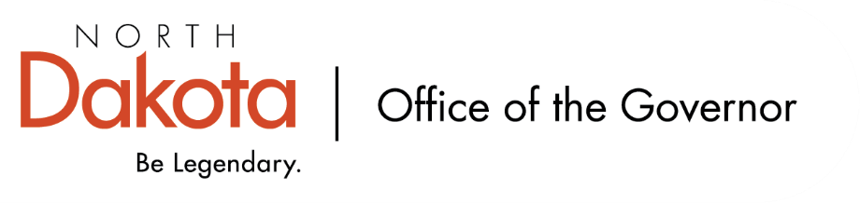

North Dakota Children’s Cabinet
Tuesday, May 19, 2026
4:00 pm, Central Time
Microsoft Teams

Members in Attendance:
- Lieutenant Governor Michelle Strinden
- Commissioner Pat Traynor
- Superintendent Levi Bachmeier
- Ms. Daniell Breland
- Ms. Shanda Cool
- Representative Jayme Davis
- Senator Kathy Hogan
- Mr. Shawn Huss
- Ms. Kimberly Jacobson
- Representative Brandy Pyle
- Mr. Russ Riehl
- Ms. Veronica Zietz

Members Absent:
- Chief Justice Lisa McEvers
- Senator Michelle Axtman
- Ms. Janell Regimbal

Other Attendees:
- Ms. Missi Baranko
- Mr. Jason Callahan
- Ms. Mary Christy
- Mr. Tim Eissinger
- Ms. Pritha Gopalan
- Mr. Jarvis Lundy
- Ms. Allison Mahoney
- Ms. Maria Neset
- Ms. Amanda Peterson
- Ms. Maureen Stover

Senator Hogan moved to approve the agenda. Mr. Riehl seconded. Motion approved.

Commissioner Traynor moved to approve the minutes from the North Dakota Children’s Cabinet March 17, 2026 meeting and April 21, 2026 meeting; Representative Pyle seconded. Motion approved.

Early Childhood Subcommittee Share Out
K-1 and Early Childhood Survey – updates. Received more than 500 responses and conducted more than 80 stakeholder interviews; representative of those in the education space throughout the state. Review of bidirectional approach to school readiness. It is not just families, but also 4-year-old programs, school districts, healthcare providers, and community organizations that share the responsibility for children’s development.

Elementary and Early Educators were similar in answers to the importance of the eight dimensions as it relates to school readiness, however the level of readiness showed that children are less prepared / ready for school based on the survey results. Review of initial results that show opportunities for improvement as it relates to school readiness, professional development opportunities, and parent education supports.

Themes emerged from the stakeholder interviews and will be taken into consideration when finalizing the report / findings on early childhood in North Dakota.

Youth with Complex, Unmet Needs Subcommittee Share Out
Definition of Guiding Values – finalizing after meeting with the eight regions in North Dakota. This work should be about the child, not systems and locally-driven, state-supported, shared responsibility solutions.

Definition of Youth with Complex Needs – finalizing and condensing from the APHSA definition. One of the biggest changes includes that youth with complex needs are identified by two or more descriptors.

Regional Facilitator Meeting – updates to include bimonthly meeting with regional facilitators. Finding some areas (zones, special ed) may have different boundaries than the regional boundaries. Six of the eight have continued to meet, focusing on youth in their region that are needing help.

Self-Assessment Tool – came from the original eight regional meetings. Hoping to capture strengths, opportunities, etc. in each region that can be used as the conversation continues around developing and implementing a system of care for children with serious behavior health issues.

Data Dashboard Updates
Working with NGA to refine definitions and have requested technical assistance to help as we build out the dashboard.

Closing remarks
- Next meeting – Tuesday, June 19, 2026 from 3:45 – 5 pm
- In-Person Retreat – Monday, August 10 at Bismarck

