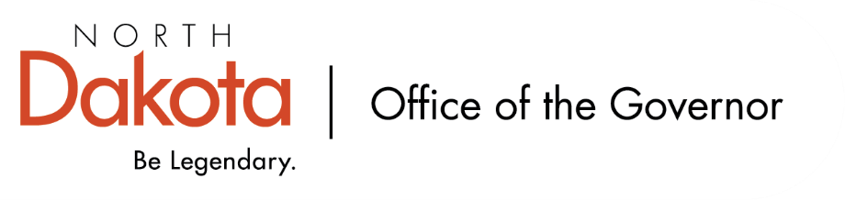

North Dakota Children’s Cabinet – Youth with Complex, Unmet Needs Subcommittee
Friday, June 12, 2026
8 – 9:30 am, Central Time
Microsoft Teams

Members in Attendance:
- Senator Kathy Hogan
- Ms. Rhonda Allery, Mountain Lakes Human Service Zone Director
- Ms. Daniell Breland, Tribal Relations Representative, Turtle Mountain Director of Child Welfare and Family Services
- Ms. Shanda Cool, Parent Representative
- Dr. Dan Cramer, NDHHS Behavioral Health Direct Services
- Ms. Kari Davis, ND DOCR, Juvenile Services Program Manager
- Ms. Cathy Federer, Director of Juvenile and Family Services, ND Court System
- Ms. Nicole Leitner, Director of Juvenile Court Service, Unit 2
- Ms. Mary McCarvel-O'Connor, NDDPI
- Ms. Janell Regimbal, Insight to Solutions
- Mr. Russ Riehl, Bismarck Public Schools
- Ms. Veronica Zietz, Protection and Advocacy Project

Members Absent:
- North Dakota Supreme Court Chief Justice Lisa McEvers
- Director Colby Braun, ND DOCR
- Mr. Tim Eissinger, Executive Director NDHHS
- Mr. Shawn Huss, Wilmac Special Education Unit
- Ms. Pamela Sagness, NDHHS Behavioral Health

Other Attendees:
- First Lady Kjersti Armstrong
- Mr. Aaron Benson
- Mr. Jason Callahan
- Ms. Mary Christy
- Ms. Lynn Flieth
- Mr. Tim Gienger
- Ms. Maria Neset
- Mr. Luke Schaefer
- Ms. Michelle Woodcock

Roll Call / Approval of Agenda
Dr. Cramer made motion to approve the minutes from the North Dakota Children’s Cabinet Youth with Complex, Unmet Needs Subcommittee on May 8, 2026; Ms. Leitner seconded. Motion approved.

Overview of Children’s Cabinet status and activities
NDCEL Conference – Moonshot. Group out of Dickinson is doing a lot of parallel work to what the Children’s Cabinet and subcommittee are focusing on. Other groups were also able to see what they are doing and working to align groups.

Regional Meetings Update. Local leadership is stepping up, groups are coming together and identifying needs. Will continue to meet bi-monthly with regional facilitators.

Working on finalizing subcommittee reports as well as Children’s Cabinet annual report. Continuing to work with National Governor’s Association on a data dashboard for North Dakota and the Children’s Funding Project to help us see where the money is going to help policy and decision makers.

Finalize Youth with Complex, Unmet Needs Definition
At the regional facilitator meeting earlier in June, they had additional thoughts and feedback; bringing back the definition to the subcommittee to review. Discussion on addiction and risky behaviors, how best to include, appropriate wording to be inclusive and not siloed.

Mr. Callahan visited with APHSA on our effort to make the definition our own as we started with their original definition; applauded our efforts.

Final draft definition will be emailed to subcommittee members for final review before forwarding to the Children’s Cabinet for their review.

Regional Self-Assessment Tool and Implementation Process
Continuing to work on self-assessment tool; important to keep front and center that we are focusing on locally-led, state supported, shared accountability.

Each region is unique and we want to look at how the state can best support each region through empowering local leadership / problem solving while providing guardrails and support from the state.

Review and discussion of self-assessment tool; how to integrate / gather feedback in both rural and urban areas; don’t want to rush this process / be intentional with what we are looking to capture and how that information will be best used.

Communication and Connecting with Outside Groups
Looking at face-to-face meetings in each region, similar to the original meetings at the end of 2025 – early 2026, to discuss what resources / services are in each region, include system specific leaders, practitioners, etc. and gain a better understanding at the local level. Group discussion on who best to be involved / invited to participate, where to look at holding the meetings, how to best engage all leaders and practitioners.

Road Show will be taking place in late September / early October. Looking to hit each region and share what the Children’s Cabinet has done and is focusing on. Will look at meeting in rural areas as well as urban.

Legislative Ideas. Doesn’t have to be new legislation but can relate to implementation of legislation already in place or potential to improve upon what is already out there. How do we have a statewide system that also provides flexibility at the local / regional level?

Next Steps and Adjourn
- Next meeting scheduled for Friday, July 10, 2026 at 8 am via Teams

