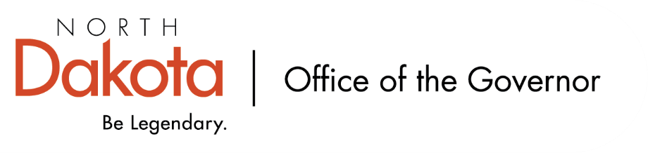

North Dakota Children’s Cabinet – Early Childhood Subcommittee
Thursday, June 25, 2026
3 pm, Central Time
Microsoft Teams

Members in Attendance:
- Lieutenant Governor Michelle Strinden
- Senator Michelle Axtman
- Superintendent Levi Bachmeier, North Dakota Department of Public Instruction
- Mr. Tim Eissinger, on behalf of Interim Commissioner Pat Traynor, North Dakota Department of Health and Human Services
- Representative Jayme Davis
- Ms. Keely Ihry, South East Education Cooperative
- Ms. Kim Jacobson, Agassiz Valley HSZ Director

Members Absent:
- Representative Brandy Pyle

Other Attendees:
- First Lady Kjersti Armstrong
- Ms. Missy Baranko
- Ms. Pritha Gopalan, The Hunt Institute
- Ms. Mary Christy
- Ms. Allison Mahoney
- Ms. Maria Neset
- Ms. Amanda Peterson
- Ms. Julie Ritter
- Mr. Maureen Stover, The Hunt Institute
- Ms. Shonda Wild

Representative Davis moved to approve the minutes from the North Dakota Children’s Cabinet Early Childhood Subcommittee meeting on May 14, 2026. Ms. Ihry seconded. Motion approved.

Early Childhood Report Q&A
Discussion on draft Early Childhood Report that The Hunt Institute has shared.

We want to make the report approachable for anyone who is looking to read it, not too lengthy, and easy to follow for legislators, policy makers, decision makers, etc. We want to show bright spots, but how best do we raise awareness of gaps and opportunities? Data dashboard will help connect the dots.

Discussions on graphics and being intentional about placement in the report, helping to make sure those reading the report can understand the relationship between the graphic and text.

Importance to recognize strong early childhood programs that the subcommittee has seen firsthand and hopes to lift up as we look at possible best practices across the state; showcasing North Dakota examples.

Will be adding in an executive summary after hearing feedback from the subcommittee. The Hunt Institute team will be reviewing feedback from today with the hopes of having a final draft version to the subcommittee for a vote before sending to the full Children’s Cabinet.

School Readiness Assessment / Screener Overview
Looking at how we can be better and defining what school readiness is; there is a disconnect between early childhood educators and elementary educators from research / interviews that The Hunt Institute did with ND stakeholders.

High level overview of recommended screeners and assessment. Discussion around importance of universal tool; large majority of superintendents Superintendent Bachmeier has visited with have said they are in support of a universal tool. Additional discussion around costs and ease of implementation that we may want to keep in mind as the work continues.

Subcommittee Check In and Adjourn
- August 10th – Children’s Cabinet In-Person Retreat @ Bismarck
- October – Children’s Cabinet Road Show
- Next Children’s Cabinet Early Childhood Subcommittee meeting: Wednesday, July 8, 2026 @ 2-3 pm on Microsoft Teams

