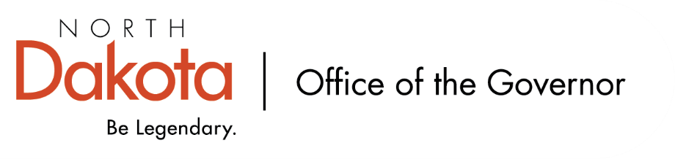

North Dakota Children’s Cabinet – Youth with Complex Needs Subcommittee
Friday, July 10, 2026
8 – 9:30 am, Central Time
Microsoft Teams

Members in Attendance:
- Senator Kathy Hogan
- Ms. Rhonda Allery, Mountain Lakes Human Service Zone Director
- Director Colby Braun, ND DOCR
- Ms. Daniell Breland, Tribal Relations Representative, Turtle Mountain Director of Child Welfare and Family Services
- Dr. Dan Cramer, NDHHS Behavioral Health Direct Services
- Ms. Kari Davis, ND DOCR, Juvenile Services Program Manager
- Ms. Chelsea Flory on behalf of Mr. Tim Eissinger, Executive Director NDHHS
- Mr. Shawn Huss, Wilmac Special Education Unit
- Ms. Nicole Leitner, Director of Juvenile Court Service, Unit 2
- Ms. Mary McCarvel-O'Connor, NDDPI
- Ms. Janell Regimbal, Insight to Solutions
- Mr. Russ Riehl, Bismarck Public Schools

Members Absent:
- North Dakota Supreme Court Chief Justice Lisa McEvers
- Ms. Shanda Cool, Parent Representative
- Ms. Cathy Federer, Director of Juvenile and Family Services, ND Court System
- Ms. Pamela Sagness, NDHHS Behavioral Health
- Ms. Veronica Zietz, Protection and Advocacy Project

Other Attendees:
- Lt. Governor Michelle Strinden
- Mr. Aaron Benson
- Mr. Jason Callahan
- Ms. Mary Christy
- Ms. Lynn Flieth
- Mr. Tim Gienger
- Ms. Maria Neset
- Mr. Luke Schaefer
- Ms. Michelle Woodcock

Roll Call / Approval of Agenda
Dr. Cramer made motion to approve the minutes from the North Dakota Children’s Cabinet Youth with Complex Needs Subcommittee on June 12, 2026; Ms. Leitner seconded. Motion approved.

Overview of Children’s Cabinet status and activities
Regional Meetings Update. Are looking to engage each region again and doing a deeper dive into strengths, weaknesses, and breaking into groups to discuss possible solutions for each region and how they may align across all eight regions. Will be starting with Region V in Fargo, Region I in Dickinson, and Region VIII in Williston in July.

Children’s Cabinet Retreat will be held on August 10 in Bismarck. Annual Report is due August 1st to the Governor and Legislature; school readiness report is in design.

Finalize Youth with Complex Needs Definition
Landed on final proposed definition for Youth with Complex Needs and brought to the subcommittee for a vote to approve and forward to the full Children’s Cabinet.

Created two definition options – one that is condensed that may be more useful for legislative / policy discussions and one that is broader and includes examples for each descriptor.

Will update to final language below:

Youth with complex needs are individuals age 0-21 which span across multiple systems, requiring support and coordinated services. Two or more of the following descriptors identify youth with complex needs:​
- Multiple systems involvement (childcare, child welfare, developmental disability, education, healthcare, juvenile justice, homeless, behavioral health services)​
- Behavioral Health Conditions with or without diagnosis (examples include but not limited to youth w/mental health conditions to include depression, PTSD, anxiety, suicidal ideation, eating disorders, substance use and other addictions. ​
- Co-occurring disorder diagnosis (Behavioral Health issues combined with developmental disabilities, physical or intellectual disabilities)​
- Risky Behaviors (examples include but not limited to running away, self-harm, truancy, expulsion or sexualized behaviors)​
- Environmental Risks (examples include but not limited to living in poverty, homelessness, living in a home with domestic violence, and at risk of abuse and neglect.)

Dr. Cramer made a motion to approve the Youth with Complex Needs definition with updated language; Ms. Allery seconded. Motion approved.

Multi-System Involvement Report – Ms. Michelle Woodcock
Ms. Woodcock provided an overview of the Multi-System Involvement Report. The target group included 123 students that were identified by special education units as having multi-system involvement in North Dakota K-12 schools.

Interest from the subcommittee on absenteeism findings; NDDPI has resources on their website that dive deeper into absenteeism, suspensions, and expulsions - https://insights.nd.gov/Education.

Discussion on findings that showed from 2022-23 and 2024-25, the target group experienced more frequent removals, more days lost, and more serious incident types as compared to peers. How do we integrate the academic and behavior team to help catch those students before it becomes a larger issue?

When comparing target students to a one-to-one statistically similar peer (same school, disability, grade, demographics, and socio-economic profile), differences persist. No single agency can solve these problems with chronic absenteeism, math and reading proficiencies, out-of-school suspensions, removal days; students with multi-system involvement represent a vulnerable subgroup and may benefit from additional supports to improve educational outcomes.

Regional Deep Dive – Locally-Led, State-Supported, Shared Accountability Regional Model
Regions are continuing to hold meetings after the initial meetings from December 2025 – February 2026. The Deep Dive meetings are intended to empower and allow local leadership and local problem solving. Each region is unique in their strengths and wants; think about more than just policy – could it be a people or process issue?

Communication and Connecting with Outside Groups
Continuing to engage with outside groups; please let Senator Hogan, Mr. Callahan, and Ms. Neset know of any additional groups to connect with.

Road Show will be taking place in late September / early October. Looking to hit each region and sharing what the Children’s Cabinet is, work being focused on, and building relationships.

Mr. Gienger shared an update that Dakota Boys and Girls Ranch will be expanding their psychiatric residential treatment services to youth as young as five. Manchester is closing and DBGR worked with NDHHS to expand their license that allows for their facility in Minot to provide Psychiatric Residential Treatment Facility services for up to 26 youth ages 5-17. Ms. Christy will forward the information emailed out this morning to the subcommittee.

Next Steps and Adjourn
- Next meeting scheduled for Friday, August 14, 2026 at 8 am via Teams

