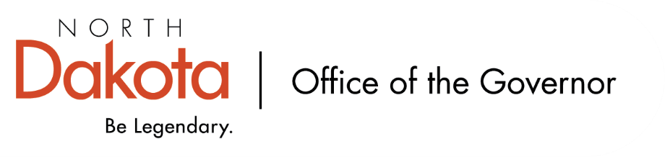

North Dakota Children’s Cabinet
Tuesday, July 21, 2026
3:45 pm, Central Time
Microsoft Teams

Members in Attendance:
- Lieutenant Governor Michelle Strinden
- Ms. Amanda Peterson on behalf of Superintendent Levi Bachmeier
- Chief Justice Lisa McEvers
- Commissioner Pat Traynor
- Senator Michelle Axtman
- Ms. Daniell Breland
- Ms. Shanda Cool
- Representative Jayme Davis
- Senator Kathy Hogan
- Representative Brandy Pyle
- Ms. Janell Regimbal
- Mr. Russ Riehl
- Ms. Veronica Zietz

Members Absent:
- Mr. Shawn Huss
- Ms. Kimberly Jacobson

Other Attendees:
- First Lady Kjersti Armstrong
- Ms. Missi Baranko
- Mr. Jason Callahan
- Ms. Mary Christy
- Ms. Cathy Ferderer
- Ms. Pritha Gopalan
- Ms. Kristen Hasbargen
- Ms. Maria Neset
- Ms. Maureen Stover
- Ms. Shonda Wild
- Dr. Mark Vollmer

Mr. Riehl moved to approve the minutes from the North Dakota Children’s Cabinet May 19, 2026 meeting; Sen. Hogan seconded. Motion approved.

Approvals
Data Dashboard – “North Star Statement” and Definitions.
This comes from our work with the National Governor’s Association Policy Academy in crafting a statement of the purpose for our data dashboard. Closely aligns with the work and wording the Children’s Cabinet is using with our Mission, Vision, and indicators.

Senator Hogan motioned to approve North Start Statement and Definitions as presented. Mr. Riehl seconded. Motion passed.

Youth with Complex Needs Definition
Youth with Complex Needs subcommittee has been working to define the youth at the focus of their work. Original definition came from the APHSA; subcommittee worked to make it more condensed and includes all youth with complex needs, not just unmet needs.

Youth with Complex Needs subcommittee has reviewed and approved it.

Senator Hogan motioned to approve the Youth with Complex Needs Definition. Ms. Cool seconded. Motion passed.

Annual Report
The content of the report is getting closer; small tweaks still to be made, but we are close and hoping to finish by the August 1, 2026 deadline. We have also received a draft design version of the report with the content the same as was sent out to the Children’s Cabinet ahead of the meeting.

Ms. Regimbal motioned to approval the Annual Report with the understanding that small tweaks and changes may be made that will not change the content of the report. Rep. Pyle seconded. Motion passed.

School Readiness in North Dakota Report
The Hunt Institute has been looking at best practices with a focus on those who are entering Kindergarten and First Grade and their school readiness. Conducted widespread sampling and interviews; focused on urban, rural, and tribal communities. Findings supported a multidimensional approach, bringing educators and parents into conversations.

Early Childhood subcommittee has provided feedback, reviewed, and approved of it.

Mr. Riehl made a motion to approve the School Readiness in North Dakota report with the understanding that small tweaks may be made that will not change the content of the report. Commissioner Traynor seconded. Motion passed.

K-12 Coordination Council – Truancy Report – Dr. Mark Vollmer
Report made possible by SB2262 from the last legislative session. The Council and NDDPI worked with UND to study attendance problems and how to support student attendance in North Dakota.

Report looked at four schools across the state in different regions – urban, rural, Tribal. Found that attendance is not attributed to just one, single cause; early intervention matters; noticeable referral and responsibility gap; everyone has a role in attendance / community expectations; mental health and wraparound capacities; Tribal partnerships are a strength; local schools need to find what works best for them / one size does not fit all.

Initial priorities may include: clarifying the state response system, explore a tiered intervention framework, examine cross-agency responsibility and capacity, study targeted support for high-need communities, and elevate attendance as an instructional priority.

This continues to be a process for the Council and will be diving into the Report later this year.

Child Safety Liaison Report – Ms. Kristen Hasbargen
This came out of last legislative session – HB1095 – with a focus on strengthening relationship between school districts and zones.

For this academic year, there were 166 public school district zones in North Dakota and HSZ offered 273 meetings. There were 78 school districts that did not have a representative attend but understand there were instances where they already have a positive relationship with the zones and did not need an additional meeting.

Meetings looked at what districts are wanting more from their zone. Discussions included attendance, safety practices, case management redesign, educational neglect and the child welfare process, how to best continue to work with and support each other, mandatory reporter training, and foster care.

Will be continuing with the next academic year. Some school districts are continuing to meet monthly with the zones depending on their needs / wants.

Opportunity to engage with the work the Youth with Complex Needs subcommittee is doing and meetings they are holding.

Early Childhood Subcommittee Share Out
Next meeting Wednesday, August 12, from 2-3 pm

Youth with Complex, Unmet Needs Subcommittee Share Out
Holding second round of regional meetings – focusing on diving deeper into programs, practices, policy, and people.

Next meeting Friday, August 14, from 8 – 9:30 am

Data Dashboard Updates
Will be finalizing request for technical assistance consultants with NGA.

Closing remarks
- In-Person Retreat – Monday, August 10 at Bismarck
- Next meeting – Tuesday, August 18, 2026 from 3:45 – 5 pm

