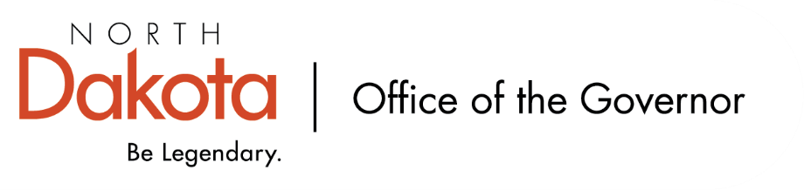

North Dakota Children’s Cabinet – Early Childhood Subcommittee
Tuesday, July 21, 2026
2:45 pm, Central Time
Microsoft Teams

Members in Attendance:
- Lieutenant Governor Michelle Strinden
- Senator Michelle Axtman
- Ms. Amanda Peterson on behalf of Superintendent Levi Bachmeier, North Dakota Department of Public Instruction
- Mr. Tim Eissinger on behalf of Commissioner Pat Traynor, North Dakota Department of Health and Human Services
- Representative Jayme Davis
- Ms. Keely Ihry, South East Education Cooperative
- Representative Brandy Pyle

Members Absent:
- Ms. Kim Jacobson, Agassiz Valley HSZ Director

Other Attendees:
- Mr. Jason Callahan
- Ms. Pritha Gopalan, The Hunt Institute
- Ms. Mary Christy
- Ms. Maria Neset
- Mr. Maureen Stover, The Hunt Institute
- Ms. Shonda Wild

Ms. Ihry moved to approve the minutes from the North Dakota Children’s Cabinet Early Childhood Subcommittee meeting on June 25, 2026. Rep. Davis seconded. Motion approved.

Early Childhood Report
Discussion on updated draft Early Childhood Report that The Hunt Institute has shared including what members felt were strengths and general feedback on the final draft product. Consensus that the report shares the story of youth and early childhood in North Dakota; impressed with the amount of data collected and interviews conducted; helps provide landscape for the subcommittee to move forward with.

Ms. Peterson made a motion to approve the Early Childhood Report as presented with the ability for minor tweaks or revisions as needed. Rep. Pyle seconded. Motion approved.

Subcommittee Check In and Adjourn
- Monday, August 10th – Children’s Cabinet In-Person Retreat @ Bismarck
- October – Children’s Cabinet Road Show
- Wednesday, August 12th - Next Children’s Cabinet Early Childhood Subcommittee meeting from 2-3 pm on Microsoft Teams

