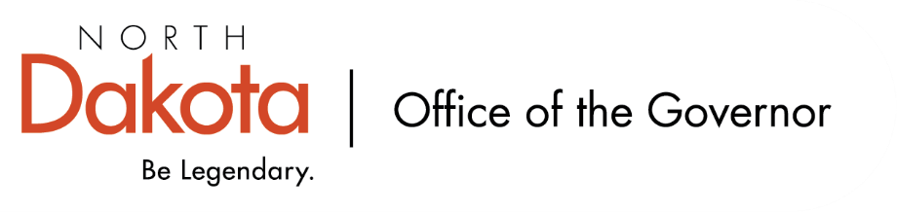
North Dakota Children’s Cabinet
10.21.2025 -- 3:45-5:00 pm
Microsoft Teams
Join the meeting now
Meeting ID: 223 123 994 526 4
Passcode: tn7b87x4

3:45-3:47 Roll Call | Chair Axtman & Mary
3:47-3:50 Approval of Meeting Minutes  2025.09.16 - Childrens Cabinet - draft minutes.docx | Chair Axtman
3:50-4:00 Operations Manual Discussion  Recommend for approval from subcommittee  2025.10.07 - North Dakota CC's Operation Manual.docx | Jason, Maria & Kim
4:00-4:15 Early Childhood Subcommittee Share Out  Next meeting: November 12, 11:00-12:00 | Sen. Axtman & Lt. Governor Strinden
4:15-4:30 HB 1556 Subcommittee Share out  Next meeting: November 14, 8:00-9:30 | Sen. Hogan
4:30-5:00 Child Well-Being Plan | Jason
5:00 Adjourn | Chair Axtman
Next Scheduled Meeting
November 18, 2025 at 3:45 pm

Reminder!! Parent Application Open
ND Boards and Commissions Application Information

