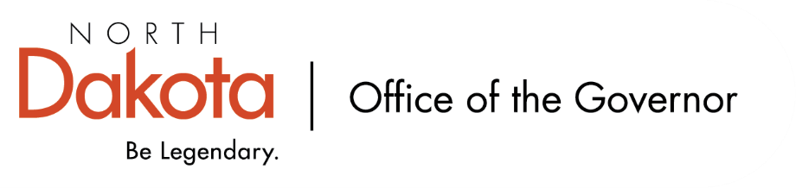

North Dakota Children’s Cabinet – Strategic Planning Subcommittee
Monday, December 8, 2025
4 p.m., Central Time
Microsoft Teams

Members in Attendance:
- Ms. Kimberly Jacobson
- Chief Justice Lisa McEvers
- Representative Brandy Pyle
- Ms. Daniell Breland

Members Absent:
- Mr. Russ Riehl

Other Attendees:
- Mr. Jason Callahan
- Ms. Mary Christy
- Ms. Allison Mahoney
- Ms. Maria Neset

Representative Pyle moved to approve the minutes from the North Dakota Children’s Cabinet Strategic Planning Subcommittee meeting on December 8, 2025; Chief Justice McEvers seconded. Motion approved.

Child Wellbeing Stakeholder Engagement
Looking to take high level framing of scorecard and share with a number of groups to help share why we are doing this, what the goal is, and how they can use it / the information included in the scorecard; groups are within the child wellbeing space, courts, service providers, family / student focus, etc. Will also looking to get their feedback. If anyone has additional feedback or recommendations on who to consider including, please let Ms. Neset and Mr. Callahan know.

Children’s Cabinet Strategic Plan Update
Brief overview of draft strategic plan. More details will be coming to update the draft with work currently being done and goals moving into the future.

ND Compass – NDSU Center for Social Research
Reviewed ND Compass, which is similar in nature to what the Subcommittee is looking to do, but is a resource pulling from public data sources; not solely focused on children. Link to 2024 year end report can be found here: ND Compass 2024

Closing remarks
- No Children’s Cabinet meeting this month
- Next Children’s Cabinet Strategic Plan Subcommittee meeting: Tuesday, January 27 @ 4pm on Microsoft Teams
- March 9, 2026 – retreat in Fargo
- Ms. Neset and Ms. Christy will follow up with Children’s Cabinet members regarding the new Statement of Interest as required by the ND Secretary of State for Governor appointed members

