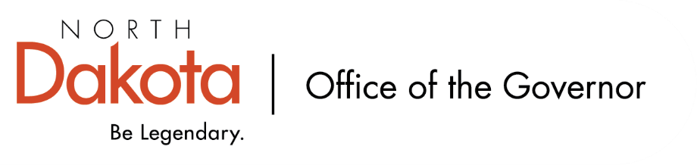

North Dakota Children’s Cabinet – Strategic Planning Subcommittee
Tuesday, September 2, 2025
4 p.m., Central Time
Microsoft Teams

Members in Attendance:
- Ms. Kimberly Jacobson
- Mr. Russ Riehl
- Representative Brandy Pyle
- Justice Lisa McEvers

Members Absent:
- Ms. Daniell Breland

Other Attendees:
- Ms. Maria Neset
- Ms. Meghan McCann
- Mr. Jason Callahan
- Ms. Mary Christy

Representative Pyle moved to approve the minutes from the North Dakota Children’s Cabinet Strategic Planning Subcommittee meeting on August 12, 2025. Mr. Riehl seconded.

Discussion around minutes and consistency with minutes for larger CC as well as preference for Subcommittee members. Approve minutes with expectation that names are replaced with “member”

Representative Pyle revised her motion to approve the minutes with revisions of removing individual names during discussions in a consistent fashion with the larger CC minutes. Mr. Riehl seconded. Revised motion approved.

Discussion on Draft By-Laws
- Goal #1 – by September, possibly October, get by-laws introduced and up for approval for full Children’s Cabinet meeting to govern internal and external processes.
  - Per AG’s office, not required to have by-laws. Discussion on if we don’t need by-laws, do we need / want them? Idea on having by-laws help the three Children’s Cabinet subcommittees work together, add to the credibility of the work being done, laying the groundwork to operate as one. Possibly consider an operations manual instead of by-laws to help guide / set the framework on how we operate.
  - Recommendation will be made to the next full Children’s Cabinet that we operate through an operations manual, not by-laws, and gauge interest to continue moving forward in this direction.
  - Recommendation to reference ND Century Code 44-04-20 and 44-04-21 regarding public notice, open meeting, and minutes. We currently provide notice of the agenda as required and take minutes.
    - Discussion on Teams availability for the public. A phone number is provided for those who don’t have Teams. Are there ways we can be more inclusive if an individual doesn’t have Teams? Discussion on looking to opportunities for the public to engage with the subcommittee or full Cabinet that aren’t virtual or even if we are virtual. Could look to flush out process for public comments when drafting the operations manual.
  - Proposed updates / thoughts from Subcommittee Members should be sent to the Subcommittee Chairs and the Forum for Youth Initiative by Friday, September 12. FYI will rework the document they have and bring to the next subcommittee meeting with the potential to bring to the October full CC meeting for review.

Mr. Riehl made a motion that the subcommittee recommends an operational guide in lieu of bylaws to help support the sustainability and creditably of the Children’s Cabinet. Justice McEvers seconded. The motion was approved.

Child Well-Being
- Timeline:
  - Build consensus by the end of 2025 / early 2026 on terminology, definition of well-being, and collect feedback; identify indicators and data sources, refine definitions / glossary in Feb – April 2026; validate the approach with partners, refine metrics, identify long-term data needs in May – June 2026; finalize strategic plan and prepare for public launch and implementation planning in July – August 2026

Mr. Riehl made a motion to approve the timeline and move forward for adaptation to the whole group. Justice McEvers seconded. The motion was approved.

Subcommittee check-in
- Discussion regarding meeting 1 x / month for an hour and if that meets the needs of the subcommittee for the work we’re wanting to do.
Mr. Riehl made a motion to meet twice a month for one hour each time starting after our October meeting. Ms. Nesset seconded. The motion was approved. Ms. Christy will send out a doodle poll to gauge best times / days of the month.

Closing remarks
- Next Children’s Cabinet Strategic Plan Subcommittee meeting: Tuesday, October 7 @ 4pm on Microsoft Teams

Mr. Riehl made a motion to adjourn. Ms. Neset seconded. The motion was approved.

