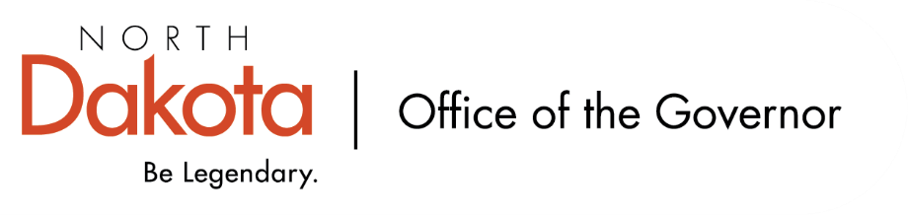

North Dakota Children’s Cabinet
Tuesday, November 16, 2025
4 p.m., Central Time
Microsoft Teams

Members in Attendance:
- Justice Lisa McEvers
- Representative Brandy Pyle
- Senator Michelle Axtman
- Senator Kathy Hogan
- Ms. Veronica Zietz
- Commissioner Pat Traynor
- Ms. Janell Regimbal
- Mr. Russ Riehl
- Mr. Shawn Huss
- Ms. Daniell Breland
- Ms. Amanda Peterson
- Ms. Maria Neset

Members Absent:
- Lieutenant Governor Michelle Strinden
- Ms. Kimberly Jacobson
- Representative Jayme Davis
- Superintendent Kirsten Baesler

Other Attendees:
- Mr. Mark Openshaw, Assistant Attorney General
- Ms. Meghan McCann
- Mr. Jason Callahan
- Ms. Mary Christy

Meeting called to order at 4:02 p.m. on Tuesday, September 16, 2025, by the Chair Senator Michelle Axtman

Commissioner Traynor moved to approve the North Dakota Children’s Cabinet minutes from August 19, 2025. Representative Pyle seconded. The motion to approve the minutes carried.

Member Update – parent application open
Due to a statutory change, the Children’s Cabinet is looking for a parent member. Individuals interested can go to Governor Armstrong’s website to learn more or apply. Ideal candidate would bring with them lived experiences, geographical representation of an area / population that may not be represented with the board members for this unique role to serve on the Children’s Cabinet.

Open Meetings & Open Records – Mr. Mark Openshaw
Mr. Openshaw is the Assistant Attorney General and has been assigned to the Children’s Cabinet. Presentation focused on open meetings and records. The primary source for information includes ND Constitution Article 11 and NDCC 44-04.

Meeting is a quorum of a governing body of a public entity discussing public business is an open meeting and committees should be abiding by this as well. Two types of meetings: regular (set by filing yearly schedule, noticed on SOS website, may discuss items not on the agenda (committee business / reports)) and special (only discuss items on published agenda; agenda must be specific / no “catch-all” entities such as “old business”). Majority of Children’s Cabinet meetings are considered regular.

The Attorney General’s website has more information, and Mr. Openshaw is available for additional questions.

Children's Cabinet Meetings AG Training September 2025 PDF.pdf

Child Well-Being Year Long Plan – Mr. Callahan and Ms. McCann
Discussion surrounding timeline. Right now we’re in the planning phase where we are setting the foundation and thinking about how we want to frame and organize our indicators of child well-being in ND.

Will look to begin outside stakeholder engagement in early 2026; dig into the data, mapping out the framework, identifying key indicators by April 2026; validate the findings with partners, refine metrics, and identify long-term data needs by June 2026; and finalize the strategic plan, prepare for public launch and implementation planning by August 2026.

Briefly talked about real world programs including: New Mexico Theory of Change, Maryland Child Well Being Theory, Annie E. Casey Child Well-Being, Child Trends Child Welfare, Indiana Graduates Prepared to Succeed, Utah Profile of a Graduate, Tennessee Child Well-Being, and New Mexico Children’s Cabinet.

Ask of the Children’s Cabinet members to share any public data sources with Mr. Callahan. We do not want to make this a data collection project, but rather to identify what is already out there and can we use it to further the subcommittee’s work, as well as the larger Children’s Cabinet, and identify areas we want to improve on.

Updates from Subcommittees
- Strategic Planning and Outcomes
  - Working to make sure everything is ready for the full CC to move forward on our goals. Instead of bylaws, will be looking to do more of an operational guide to provide flexibility and structure for the subcommittees and full Children’s Cabinet. Will be reviewing the operational guide draft at the next subcommittee meeting and plan to share a draft for full cabinet by November.
- HB 1556
  - Held their first meeting on Friday, September 5, 2025. The subcommittee heard from four subdivisions relating to both policy and provider experiences (Behavioral Health, Juvenile Courts, NDHHS, NDDPI). Each had distinct perspectives and identified gaps and challenges.
  - The subcommittee also discussed what is working and what can be improved upon. System of care in some regions are working well, schools have strong links with their service centers – but it’s different region by region, town by town.
  - Will meet virtually for 2 hours / month moving forward
- Early Childhood
  - First meeting will be next week on the 22nd
  - Will be doing site visits of early childhood centers in October

Closing remarks
- Ms. McCann will be departing the Forum next Friday
- Next Children’s Cabinet meeting: Tuesday, October 21st @ 4pm on Microsoft Teams

Meeting adjourned at 5:05 p.m. on Tuesday, August 19, 2025, by the Chair Senator Michelle Axtman

