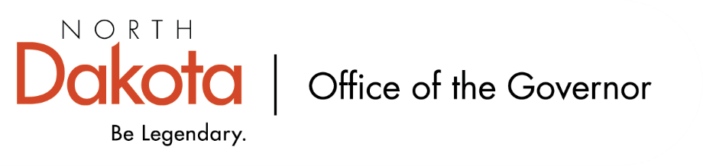
North Dakota Children’s Cabinet
9.16.2025 -- 4:00-5:00 pm
Microsoft Teams
Join the meeting now
Meeting ID: 223 123 994 526 4
Passcode: tn7b87x4

Dial in by phone
+1 701-328-0950,,846211381# United States, Bismarck
Find a local number
Phone conference ID: 846 211 381#

4:00-4:05 Roll Call | Chair Axtman & Mary
4:05-4:10 Approval of Meeting Minutes  2025.08.19 - Childrens Cabinet - draft minutes.docx | Chair Axtman
4:10-4:15 Member Update – Parent Application Open  ND Boards and Commissions Application Information | Maria Neset
4:15-4:30 Open Meetings & Open Records  - Presentation & Questions | Mark Openshaw
4:30-4:50 Child Well-Being Yearlong Plan  - What could this look like? -- State Examples  - Ask of the Cabinet – Public Data Sources | Jason & Meghan
4:50-5:00 Updates from Subcommittees  - Strategic Planning and Outcomes  - HB 1556  - Early Childhood | Co-Chairs of Subcommittees
5:00 Adjourn | Chair Axtman
Next Scheduled Meeting
October 21, 2025 at 4:00 PM*

