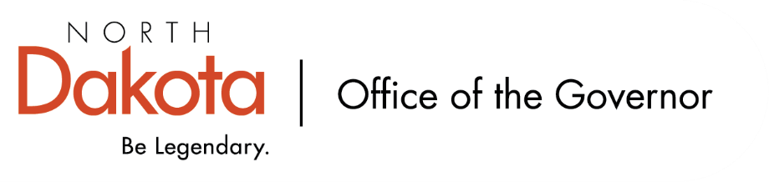

North Dakota Children’s Cabinet – Early Childhood Subcommittee
Monday, September 22, 2025
3:45 p.m., Central Time
Governor’s Conference Room and Microsoft Teams

Members in Attendance:
- Ms. Emily O’Brien, North Dakota Department of Health and Human Services
- Commissioner Pat Traynor, North Dakota Department of Health and Human Services
- Lieutenant Governor Michelle Strinden
- Senator Michelle Axtman
- Representative Jayme Davis
- Superintendent Kirsten Baesler, North Dakota Department of Public Instruction

Members Absent:

Other Attendees:
- Ms. Jessica Thomasson, North Dakota Department of Health and Human Services
- Ms. Kay Larson, North Dakota Department of Health and Human Services
- Ms. Keely Ihry, South East Education Cooperative
- Ms. Amber Fast, Office of the Governor
- Ms. Maria Neset, Office of the Governor
- Ms. Amy Cleary, GA Group
- Mr. Mike Gulick

Lt. Gov. Strinden moved to approve the minutes from the North Dakota Children’s Cabinet Early Childhood Subcommittee meeting on July 28, 2025. Representative Davis seconded. Motion approved.

Early Childhood Presentation from NDHHS – Ms. Thomasson, Ms. Larson
Presentation focused on Child Care. ND initiatives include increasing the number and distribution of quality childcare spaces available to working families, increasing the number and percentage of eligible working families who can access childcare assistance, and achieve a more proportionate distribution of childcare assistance across the state.

Discussion around CCAP programmatic rates over time; ND reviews rates annually.

Presentation focused on Best-in-Class program that expands access to high quality experiences up to pre-k ages. Looking to work on how best NDHHS can collect data well and the ability to use it across systems to positively impact students as they grow (K-12) while following applicable privacy / legal guidelines.

Childcare Presentation from GA Group – Ms. Cleary
Childcare emerged as one of North Dakota’s biggest workforce challenges. Partnered with South East Education Cooperative (SEEC) to conduct interviews and found that what was more important was availability, affordability, and quality. Lawmakers want more data to validate the results and to justify adjusting funding.

Discussion around childcare assistance, range of assistance to families, and accurate data to share how much parents are paying for childcare.

Upcoming Events
Two interim committee studies being looked at by the Human Services Committee, chaired by Senator Davison, will meet on November 19, 2025, regarding licensing and program evaluation.

October 6, 2025, Best in Class visits. The Early Childhood Subcommittee has invited the full Children’s Cabinet and local legislators to join them. Will be visiting five Best in Class sites including YMCA Northern Sky in West Fargo, Mapleton Public School, Maple Valley Public School, Valley City Public School and Circle of Friends Preschool.

Next Children’s Cabinet Early Childhood Subcommittee meeting: Wednesday, October 8 @ 2pm on Microsoft Teams

Chair Axtman adjourned the meeting.

