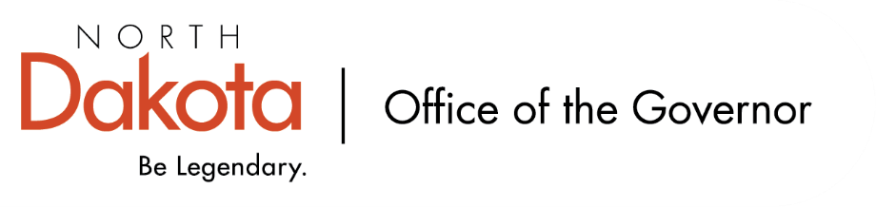
North Dakota Children’s Cabinet
Early Childhood Subcommittee
10.6.2025 – 11:00 am – 12:00 pm
Maple Valley Public School
207 Broadway, Tower City, ND

Maple Valley Public School
- Maple Valley Public School is an HHS approved four-year-old program.
- This is the second year Maple Valley Public School is participating in Best in Class.

School leadership: Superintendent Dan Larson

Classroom educators: Abigail Meyer

Agenda:
Tour Maple Valley Public School + Meet Staff
Visit with youth enrolled in the Best in Class program
Visit with Superintendent Larson and educators

