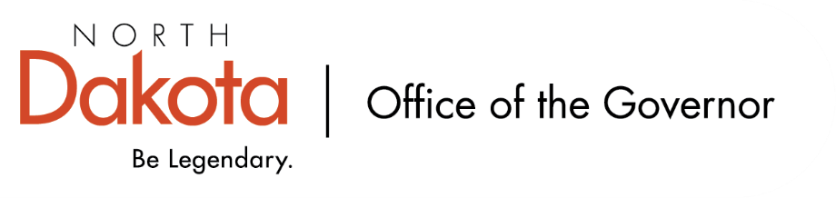
North Dakota Children’s Cabinet
Early Childhood Subcommittee
10.6.2025 – 9:30 – 10:30 am
Mapleton Public School
300 First Street, Mapleton, ND

Mapleton Public School
- Mapleton Public School is an HHS approved four-year-old program.
- This is the second year Mapleton Public School is participating in Best in Class.

School leadership: Principal Jenna Farkas

Classroom educators: Skylar Fosse

Agenda:
Tour Mapleton Public School + Meet Staff
Visit with youth enrolled in the Best in Class program
Visit with Principal Farkas and educators

