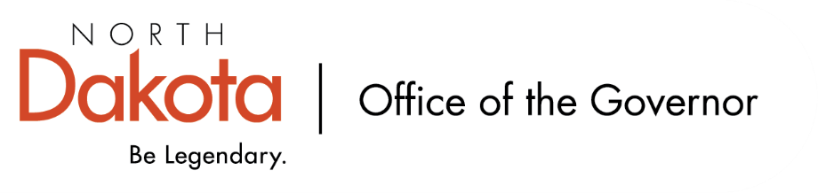
North Dakota Children’s Cabinet
Early Childhood Subcommittee
10.6.2025 – 1:30 – 2:15 pm
Valley City Public School
1150 Central Avenue North, Valley City, ND

Valley City Public School
- Valley City Public School is an HHS approved four-year-old program.

School leadership: Superintendent Josh Johnson; Principal Becky Goven

Classroom educators: Rebecca Berntson, Kayleen Marthaler

Agenda:
Tour Valley City Public School + Meet Staff
Visit with youth enrolled in the Best in Class program
Visit with Superintendent Johnson, Principal Goven and educators

