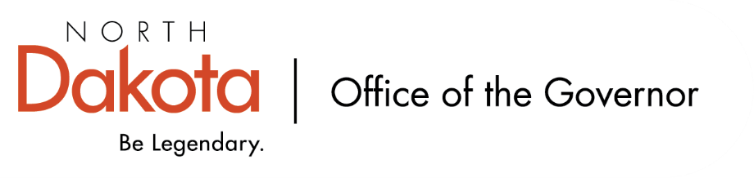
North Dakota Children’s Cabinet
Early Childhood Subcommittee
10.6.2025 – 8:15 – 9:15 am
YMCA Northern Sky
109 Third Street East, West Fargo, ND

YMCA Northern Sky
- This is the third year the YMCA Northern Sky is participating in Best in Class.
- This program is a Bright and Early ND Step 3 quality rated childcare center.

Facility leadership: Lori Thoemke, VP of Learning Centers; Tania Zerr, Learning Center Executive Director; Nicole Rentz, Regional Director; Cierra Meisch, Site Director; Nicole Jordal, Teacher Specialist

Classroom educators: Stacy Norlock / Zoey Dirkes; Ashley Krsnak / Marissa Wong; Elyse Frenzel / Savannah Berg.

Agenda:
Tour YMCA Northern Sky + Meet Staff
Visit with youth enrolled in the Best in Class program
Visit with YMCA Team

