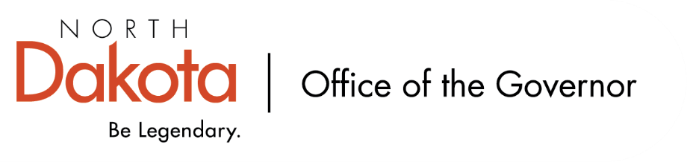
North Dakota Children’s Cabinet
10.7.2025 -- 4:00-5:00 pm
Microsoft Teams
Join the meeting now
Meeting ID: 291 835 951 858 0
Passcode: J8yB9FM6

4:00-4:05 Roll Call/Approval of the Agenda | Maria/Kim
4:05-4:10 Approval of Minutes from 9.2.2025  2025.09.02 - ND CC Strategic Planning Subcommittee - draft minutes.docx  Also in Teams > Strategic Plan Subcommittee > 2025.09 | Maria/Kim
4:10-4:20 Discuss Draft Operations Manual  - Provide feedback for revision, additions, etc.  2025.10.06 - North Dakota CC's Operation Manual.docx  Also in Teams > Strategic Plan Subcommittee > 2025.10 | Jason & Maria
4:20-4:50 Discuss Child Well-Being and Data Indicators | Jason & Maria
4:50-4:55 Subcommittee Check In & Adjourn  - Meeting cadence and length – adjust?  - Other suggestions? | Maria/Kim
4:55-5:00 Adjourn | Maria/Kim
Next Scheduled Subcommittee Meeting
- Tuesday, November 4 at 4:00 PM

