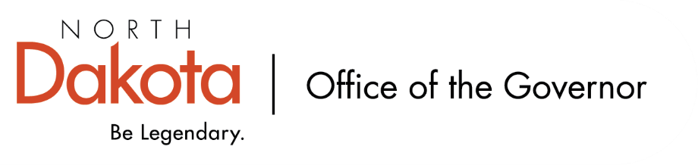

North Dakota Children’s Cabinet – Strategic Planning Subcommittee
Tuesday, October 7, 2025
4 p.m., Central Time
Microsoft Teams

Members in Attendance:
- Ms. Kimberly Jacobson
- Justice Lisa McEvers
- Mr. Russ Riehl
- Representative Brandy Pyle
- Ms. Daniell Breland

Members Absent:

Other Attendees:
- Ms. Maria Neset
- Mr. Jason Callahan
- Ms. Mary Christy

Mr. Riehl moved to approve agenda; Representative Pyle seconded. Motion approved

Justice McEvers moved to approve the minutes from the North Dakota Children’s Cabinet Strategic Planning Subcommittee meeting on September 2, 2025; Representative Pyle seconded. Motion approved.

Discuss Draft Operations Manual
Decision was made at September meeting to create an operations manual; something more inward facing and informal, a living and breathing document that future subcommittee and Children’s Cabinet members can make suggested changes or updates to and would follow appropriate channels for approval.

The Operations Manual includes our mission, vision, purpose; explains it was created by law, NDCC 54-07-13 (updated version will cite statutory citation); membership, meetings, subcommittees; process for accepting stakeholder input / feedback (if there is any recommendations or suggestions on the process, please send to Mr. Callahan); accountability, leadership, and how the rules can be amended (updated version will change “rules” to “manual”).

Chair Jacobson asked if there was any opposition to bringing operations manual to full children’s cabinet and there was no opposition. There was consensus among the Strategic Planning Subcommittee to take the document forward to full Children’s Cabinet for review and revisions at their October 21, 2025 meeting.

Discuss Child Well-Being and Data Indicators
Timeline – subcommittee is building out the structure, identifying metrics, and continuing to have conversations around what does child well-being mean in ND. Following this work, the next step is taking our findings / models to stakeholders. Subcommittee asked to be thinking about who those stakeholders are, who do we want and need to be engaging?

Discussion surrounding roadmap and looking at big picture before narrowing down to more localized data sets. Big picture focuses on economic, family & community, education, and health & safety. Shared an example from The Hunt Institute (https://pn3policy.org/pn-3-state-policy-roadmap-2025/nd/) that showed where North Dakota lands compared to the other 49 states.

Mr. Callahan created a spreadsheet for the subcommittee to input data sources, reports, and documents that will help the subcommittee make informed decisions regarding themes. Asked for input to be completed by October 31, 2025. Will also be asking the full Children’s Cabinet to utilize and add to the spreadsheet at the October 21, 2025 meeting.

Subcommittee check-in

Ms. Christy will be sending out a doodle poll to gauge the best day / time for a second monthly meeting for the Subcommittee.

Closing remarks
- Next Children’s Cabinet Strategic Plan Subcommittee meeting: Tuesday, November 7 @ 4pm on Microsoft Teams

