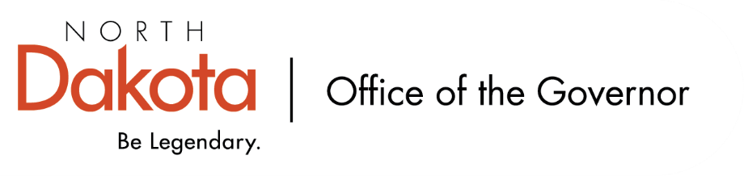

North Dakota Children’s Cabinet – Early Childhood Subcommittee
Wednesday, October 8, 2025
2 p.m., Central Time
Microsoft Teams

Members in Attendance:
- Lieutenant Governor Michelle Strinden
- Senator Michelle Axtman
- Superintendent Kirsten Baesler, North Dakota Department of Public Instruction
- Ms. Keely Ihry, South East Education Cooperative
- Representative Jayme Davis
- Commissioner Pat Traynor, North Dakota Department of Health and Human Services

Members Absent:

Other Attendees:
- Ms. Amanda Peterson
- Ms. Shonda Wild
- Ms. Kay Larson
- Ms. Maria Neset
- Ms. Mary Christy

Commissioner Traynor moved to approve the minutes from the North Dakota Children’s Cabinet Early Childhood Subcommittee meeting on September 22, 2025. Superintendent Baesler seconded. Motion approved.

South East Education Cooperative – Child Care Aware of ND – Ms. Ihry
Ms. Ihry has been invited to join the EC Subcommittee and accepted. Ms. Ihry is Director of Student Services for SEEC and they hold the Child Care Aware contract from NDHHS (have held the contract since October 2021).

Child Care Aware provides support in opening, running, or expanding a childcare business. Provide information and training on health and safety topics for childcare providers. Assist established childcare programs through professional development opportunities, business management tools, and curriculum. Help parents and families in researching and choosing childcare.

Two programs to focus on early learning (educators, families, youth): Best in Class and SEEDS of Early Learning. Discussion relating to professional development opportunities, coaching. Those who have participated in SEEDS of Early Learning training will have an opportunity to participate in a national study through LENA. Piloting with 10 classrooms to look at collecting data on early literacy skills in children birth to five; data will be used to show the need for professional development and coaching.

Best in Class Site Visit Debrief
Great visits all around. In some of the more rural areas, we heard how the programs find families and they are getting a good return rate for siblings. Discussion on differences between our rural and urban areas. Harder to serve as many 4-year-olds in larger cities; how can we better connect the Best-in-Class teachers to kindergarten teachers in these areas?

Discussion surrounding data from Best in Class. This is the first year we have data as the first cohort of students are in 3rd grade now and use the STARS system. Could look into the opportunity to access the interim assessment data, if taken through the state / NDA+, but if the district used a different interim assessment, the state would not have access. The numbers will be small with the first cohort but would give the subcommittee a starting point.

Discussion around how schools or childcare centers find out about Best in Class and requirements to be able to apply.

The Hunt Institute Early Childhood Debrief
Received data / snapshots of where ND is at compared to others:

- All State Profiles by The Hunt Institute
- North Dakota Early Childhood Data Packet by The Hunt Institute
- 2025 Early Childhood Issue Brief by The Hunt Institute
- Prenatal-to-3 Policy Impact Center ND Roadmap

To those from North Dakota who attended, New Mexico stood out. They’re making big changes and will be an interesting one to watch. Discussion regarding information / studies from Hunt and can the subcommittee bring it together and tailor to North Dakota, how our kids are doing, and what services do we need to provide?

Upcoming Events
Next Children’s Cabinet Early Childhood Subcommittee meeting: Wednesday, November 12 @ 11 am - 12pm on Microsoft Teams

