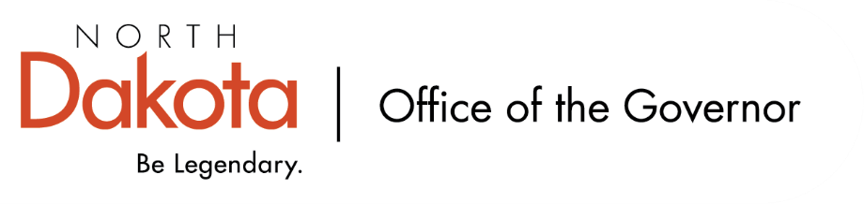

North Dakota Children’s Cabinet – HB1556 Subcommittee
Friday, October 10, 2025
8 – 9:30 am, Central Time
Microsoft Teams

Members in Attendance:
- Senator Kathy Hogan
- Ms. Janell Regimbal, Insight to Solutions
- Mr. Shawn Huss, Wilmac Special Education Unit
- Dr. Dan Cramer, NDHHS Behavioral Health Direct Services
- Ms. Pamela Sagness, NDHHS Behavioral Health
- Ms. Mary McCarvel-O'Connor, NDDPI
- Director Colby Braun, ND DOCR
- Ms. Kari Davis, ND DOCR, Juvenile Services Program Manager
- Ms. Nicole Leitner, Director of Juvenile Court Service, Unit 2
- Ms. Cathy Federer, Director of Juvenile and Family Services, ND Court System

Members Absent:
- Ms. Veronica Zietz, Protection and Advocacy Project
- Ms. Rhonda Allery, Mountain Lakes Human Service Zone Director
- Senator Michelle Axtman

Other Attendees:
- Mr. Jason Callahan, Forum for Youth Investment
- Ms. Michelle Woodcock, NDDPI Special Education Coordinator
- Ms. Maria Neset, Governor's Office
- Ms. Mary Christy, Governor's Office

Roll Call / Approval of Agenda

Approval of Minutes / Identify Themes from September 5, 2025 Meeting
Updates include:
- Section A – what does success look like?
  - MST, not MFT
  - Add bullet point: “Child centered with a family focus and shared responsibility across all systems”
- Juvenile Court Presentation from Ms. Leitner. “…access to, and misuse of, detention…” language addition
- Rename Mr. Braun’s presentation header to “Division of Juvenile Services / NDDOCR”
- Remove Ms. Peterson’s name from the Public Education Presentation; added Ms. McCarvel-O’Connor’s name

Will look to approve minutes at the HB1556 Subcommittee meeting on Friday, November 14, 2025.

Shared Definition of “complex needs” youth across systems
Discussion on the need for a definition to assist in the work the subcommittee is doing; promote early intervention, guide conversations relating to data collection and sharing, help identify service eligibility, opportunities, areas for improvement / growth. Good starting point with the APHSA definition – “State and local agencies define complex or high-acuity youth as those whose needs span across multiple systems, requiring intensive coordination and support.”

Definition could also include parental rights, parental needs / concerns. Continuum of care / services could be something to include as youth cases vary in severity of complexity. Look at real life situations the subcommittee has experienced as we get closer to having the definition established.

Discussion on age ranges we focus on; nothing set in HB1556 for specific age range.

Discussion on additional external experts or groups not represented as a part of this subcommittee.

Potential approach to regional structure for systems of care
Review of Regional Human Service Centers and Zones throughout North Dakota. Human Service Centers are becoming Behavioral Health Clinics, due to legislative action to rename, as there was confusion about what the differences are between the two.

Discussion on how we provide services throughout the state to our children and families – can we make this easier or more efficient with the regional structures already in place? Are there areas of the state where we are seeing something different / established / working well that we can replicate, look into what resources are lacking / in abundance?

Strengths and gaps of potential data sharing agreements to ensure transparency and nimbleness of system support of “complex needs” youth
Discussion on priority on data sharing. Topic has been visited in the past; districts would need to submit a MOU to share data. Without being able to share data, it can become a barrier to being able to discuss our youth. On the flip side, with the data that is out there, are we using it as best we can? Could there be a data collection process throughout the state so that it is consistent, more accessible across systems to be able to use? Get rid of the multiple applications / barrier to service. What role does AI play in being able to help with data collection, review, and recommendations?

Mr. Callahan will look to create a spreadsheet similar to Strategic Plan Subcommittee to begin gathering data points.

Closing Comments
Next meeting scheduled for Friday, November 14, 2025 at 8 am via Teams

