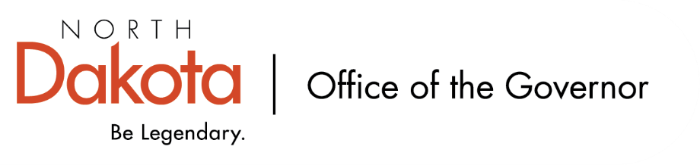
North Dakota Children’s Cabinet
1556 Subcommittee
10.10.2025 -- 8:00-9:30 am
Microsoft Teams
Join the meeting now
Meeting ID: 290 766 270 402 5
Passcode: of9ax7UF

8:00-8:10 Roll Call / Approval of Agenda  Welcome, Introductions & What is the 1556 Subcommittee asked to accomplish? | Senator Hogan/Jason
8:10-8:40 Approval of Minutes from 9.5.2025 & Identify Themes of September 5th Minutes  2025.09.05 - HB 1556 - Draft Final Minutes.docx | Jason/Senator Hogan
8:40-8:55 Shared Definition of “complex needs” youth across systems | Jason & Senator Hogan
8:55-9:10 Discuss potential approach to regional structure for systems of care? | Jason & Senator Hogan
9:10-9:25 What are the strengths and gaps of potential data sharing agreements to ensure transparency and nimbleness of system support of “complex needs” youth? | Jason & Senator Hogan
9:25-9:30 Next steps & Adjourn | Senator Hogan & Jason
Next Scheduled Subcommittee Meeting
- November 14, at 8 AM via Teams

