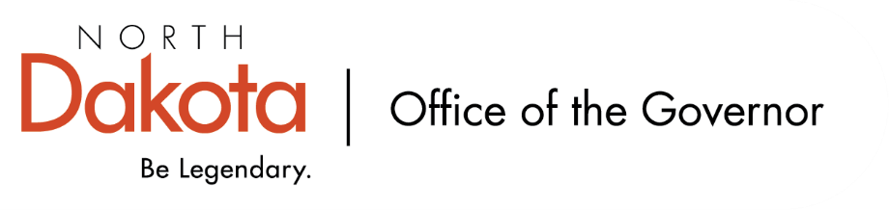

North Dakota Children’s Cabinet
Tuesday, October 21, 2025
3:45 p.m., Central Time
Microsoft Teams

Members in Attendance:
- Lieutenant Governor Michelle Strinden
- Senator Michelle Axtman
- Justice Lisa McEvers
- Superintendent Kirsten Baesler
- Commissioner Pat Traynor
- Senator Kathy Hogan
- Representative Brandy Pyle
- Ms. Daniell Breland
- Mr. Shawn Huss
- Ms. Kimberly Jacobson
- Mr. Russ Riehl
- Ms. Veronica Zietz

Members Absent:
- Representative Jayme Davis
- Ms. Janell Regimbal

Other Attendees:
- Ms. Cathy Federer
- Mr. Jason Callahan
- Ms. Maria Neset
- Ms. Mary Christy

Commissioner Traynor moved to approve the North Dakota Children’s Cabinet minutes from September 16, 2025. Senator Hogan seconded. The motion to approve the minutes carried.

Operations Manual Discussion – recommend for approval from Strategic Plan Subcommittee
Operations Manual meant to be an internal working document to give both the subcommittee and Children’s Cabinet groundwork to build on as we’re doing our work. The Manual also includes a brief history, references to the Century Code, and legislative changes.

Discussion around how often the Manual would it be reviewed / updated. Other Cabinet’s review annually to make sure it is current and reflects best practices, but we can include if the Cabinet would like to add this to the Manual.

Group consensus to include Mission and Vision at the top of our agendas.

Senator Hogan moved to approve Operations Manual as presented, attached, and discussed with the addition of annual reviews and discussion at full children’s cabinet meeting language. Commissioner Traynor seconded. The motion carried.

Early Childhood Subcommittee Share Out
Discussion on Best in Class visits on the eastern side of the state in October. These were intertwined in childcare facilities, connections with public school, and independent facilities.

Discussion moved into October Subcommittee meeting on how we gather data and how do we expand this to reach more communities. During Best in Class visits, teachers shared how important their coach was in the success of their program in addition to the grant funding.

Ms. Keely Ihry, South East Education Cooperative, will be joining their subcommittee.

A handful of Children’s Cabinet members attended The Hunt Institute conference in late September. Handouts were provided that showed areas ND did well in and areas we can improve in; group felt it was a good learning experience brought back to the appropriate subcommittees.

Next meeting – November 12, 2025 from 11 am – 12 pm.

HB1556 Subcommittee Share Out
Senator Hogan attended a Homeless Youth Summit where six other states are working on issues that HB1556 is also working on; the problems / concerns the subcommittee and Children’s Cabinet are working on are not limited to North Dakota.

Subcommittee is looking at what a complex need is; will use the APHSA definition (“State and local agencies define complex or high-acuity youth as those whose needs span across multiple systems, requiring intensive coordination and support.”) as our base. Discussion turned on how we can regionalize responses (looking at 8 regional jurisdictions that are mapped out as clinical behavioral health centers) and systems collaboration, combination of how do we review cases / needs of children without disclosing personal information / data sharing agreements. Will look at building a checklist that includes nonidentifiable information, but certain characteristics, to try and gather how many and what systems are involved in each case.

Next meeting – November 14, 2025 from 8 – 9:30 am.

The Forum for Youth Investment – slide deck
Through November, looking to establish structure of how we report child wellbeing. A second tab was added to our indicator spreadsheet to capture / identify stakeholders from agencies, local education agencies, parent groups, regional organizations – ask of the group to input their recommendations as to who to engage.

In thinking about four larger areas to focus on, Annie E Casey resonated with the Cabinet – socio determinates / indicators including economic well-being, education, health, and family & community factors. Can begin to look at how do we move the needle in these areas looking at children 0-21 in North Dakota after we have the indicators set.

Discussion surrounding data and how do we showcase where North Dakota lands in certain areas; want to make it easily digestible, tell the story of the children’s Cabinet. Referenced The Hunt Institute’s handouts from Cabinet members who attended their conference that resonated as to how we can share ND’s story.

Strategic Plan Subcommittee will start meeting twice per month and will continue moving forward in what we’re doing; looking at big picture and can start narrowing down as we move forward.

Closing remarks
- We have created a slide deck for Subcommittee chairs to update ahead of each monthly meeting to capture our progress; running record of where we have been, where we are at, and where we are going.
- Will be looking to do another in person full cabinet retreat late winter / early spring. Ms. Christy will get a doodle poll sent out to capture what dates may work best.
- Next Children’s Cabinet meeting: Tuesday, November 18th @ 3:45 pm on Microsoft Teams

