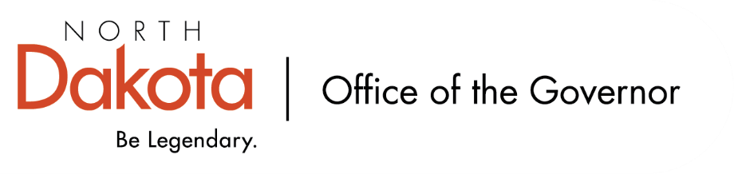

North Dakota Children’s Cabinet – Strategic Planning Subcommittee
Monday, November 10, 2025
4 p.m., Central Time
Microsoft Teams

Members in Attendance:
- Ms. Kimberly Jacobson
- Justice Lisa McEvers
- Representative Brandy Pyle
- Mr. Russ Riehl

Members Absent:
- Ms. Daniell Breland

Other Attendees:
- Mr. Jason Callahan
- Ms. Maria Neset
- Ms. Mary Christy

Ms. Jacobson moved to approve the minutes from the North Dakota Children’s Cabinet Strategic Planning Subcommittee meeting on October 7, 2025; Representative Pyle seconded. Motion approved.

Alignment Discussion
Discussing around planning for and collecting stakeholder groups feedback. We want to be intentional sharing our purpose and the wellbeing scorecard.

Stakeholders could include Education, HHS, Justice, policy makers, philanthropy, Tribal Organizations, youth advisory, parent groups are initial thinking, not exhaustive / exclusive list. Discussion focused on narrower groups within each broad stakeholder group listed to consider as we move forward, looked at who would be missing or who else the subcommittee would want to include that represent the main domains we’re looking at (economic wellbeing; health and safety; family and community; education).

Would be looking to start engaging stakeholder groups in early 2026.

Walk Through Well-Being Indicators
Question posed: what does it mean to have all children prepared? Are the indicators helping the subcommittee align with the purpose of what we’re working towards and the audience we’re wanting to provide the scorecard to? Discussion about balancing broad, high-level indicators and more granular level data and sharing. This is an iterative process; things will evolve as we dig into them, we will be able to build consensus to share with our stakeholders, and move the work forward.

Discussion on who the stakeholders are / will be; importance of vetting who our stakeholders are, what areas / groups they represent, how many will we engage / ask to participate. Our goal will be to provide a high-quality product that can be used by external experts and stakeholders as something that can provide value for further conversation.

Subcommittee check-in
Ms. Neset and Mr. Callahan will work to define themes more concretely; will look at indicators and pull what we think is of value and align that with what we are doing, look at if it is helping to provide a picture of child wellbeing.

Ms. Christy will prepare an online form for the Subcommittee to review indicators, help prioritize indicators, add any that are missing.

Subcommittee asked to start thinking strategically about who should be involved in the stakeholder groups

Closing remarks
- Next Children’s Cabinet Strategic Plan Subcommittee meeting: Tuesday, November 25 @ 4pm on Microsoft Teams

