North Dakota Children’s Cabinet –
Early Childhood Subcommittee
11.12.2025 – 11:00 am – 12:00 pm
Microsoft Teams
Join the meeting now
Meeting ID: 262 496 521 690 6
Passcode: 9w3ea3hR

Vision: The North Dakota Children’s Cabinet ensures that all children are prepared and successful, equipped with the skills, knowledge, and resilience to thrive in an every-changing world.

Mission: The North Dakota Children’s Cabinet collaborates to elevate what works and drive towards a seamless network of services and supports that meet the needs of every child and family.

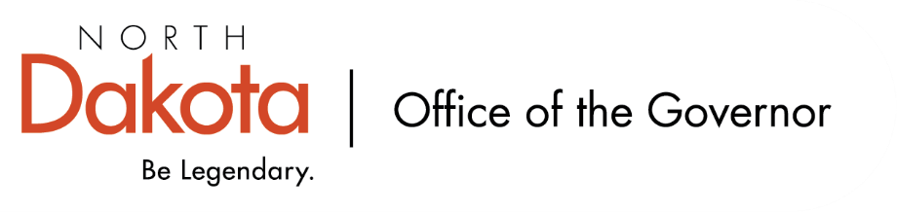
11:00-11:05 Roll Call/Approval of the Agenda | Sen. Axtman &  Lt. Governor Strinden
11:05-11:07 Approval of Minutes from 10.8.2025  2025.10.08 - ND CC Early Childhood Subcommittee - draft minutes.docx | Sen. Axtman &  Lt. Governor Strinden
11:07-11:10 Update on Technical Assistance Contract for the EC Subcommittee
11:10-11:40 Review List of Early Childhood Data Sets
- https://pn3policy.org/pn-3-state-policy-roadmap-2025/nd/
- Children’s Cabinet Public Data Spreadsheet – EC Data
11:40-11:50 Data Dig – Time to ask questions and discuss solutions!
  - Data IDs for cross-system efforts
  - Where does child care fall into the data alignment?
  - Who is driving the data matching and alignment?
  - How can the current data dashboards be shared and widely used for the public?
  - How far away are we to saying we will have data that is usable and statistically relevant to showing results?
11:50-11:55 Subcommittee Check In & Adjourn | Sen. Axtman &  Lt. Governor Strinden
11:55-12:00 Adjourn | Sen. Axtman &  Lt. Governor Strinden
Next Scheduled Subcommittee Meeting
- Wednesday, December 17 from 11 am – 12 pm

