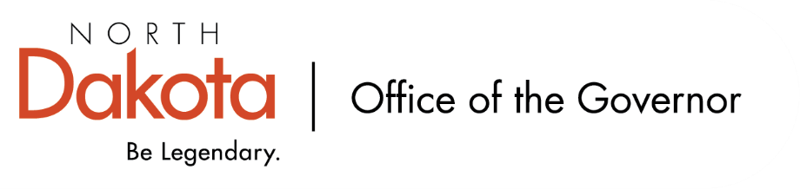

North Dakota Children’s Cabinet – Early Childhood Subcommittee
Wednesday, November 12, 2025
11 a.m., Central Time
Microsoft Teams

Members in Attendance:
- Lieutenant Governor Michelle Strinden
- Senator Michelle Axtman
- Superintendent Kirsten Baesler, North Dakota Department of Public Instruction
- Commissioner Pat Traynor, North Dakota Department of Health and Human Services
- Representative Jayme Davis
- Ms. Keely Ihry, South East Education Cooperative

Members Absent:

Other Attendees:
- Ms. Missi Baranko
- Ms. Mary Christy
- Ms. Kelly Eppley, The Hunt Institute
- Ms. Kay Larson
- Ms. Maria Neset
- Deputy Commissioner Emily O’Brien
- Ms. Amanda Peterson
- Ms. Julie Ritter
- Mr. Stanley Schauer

Ms. Ihry moved to approve the minutes from the North Dakota Children’s Cabinet Early Childhood Subcommittee meeting on October 8, 2025. Representative Davis seconded. Motion approved.

Update on Technical Assistance Contract for Early Childhood Subcommittee
The Forum for Youth Investment is helping with the Strategic Plan, HB1556, and full Children’s Cabinet. Starting in December, The Hunt Institute will be joining the subcommittee to provide specialized support in the area of early childhood.

Ms. Eppley, Director of Early Learning with The Hunt Institute briefly introduced herself. Work with experts and data across the country to help states create goals and move those goals forward. Will be working with Ms. Eppley to provide support, best practices, research, and report their findings with the subcommittee.

Review List of Early Childhood Data Sets
- https://pn3policy.org/pn-3-state-policy-roadmap-2025/nd/
- https://pn3policy.org/pn-3-state-policy-roadmap-2025/nd/outcomes
- Children's Cabinet Public Data Spreadsheet - EC Data

Prenatal-to-3 Policy Discussion on North Dakota specific results. Graphic reads like a scorecard and the hope is to bring something similar to the work we are doing; show the work we are doing so that policy makers, stakeholders, the public, etc. has a better idea of where the children in ND land in certain areas.

Group discussed the broader policy goals listed. There are some that while the data gives good food for thought, may not fall within the subcommittee’s focus. Additional questions / requests to find out where the data was pulled from or collected from, does the state have data that also reflects these results, narrow scope for the results (0-3) and can we broaden the age range?

Discussion relating to the data source spreadsheet. There are good things happening in the 0-5 space that may not be reflected on the spreadsheet; we want to try and capture as much as we can for discussion and consideration. The Strategic Planning subcommittee will begin to weed their way through the spreadsheet and identifying priorities. Asking the subcommittee to input their ideas by end of day Friday, November 14, 2025.

Data Dig – Time to ask questions and discuss solutions
Discussion among the group:
- Data ID’s for cross-systems efforts
  - Best in Class students participate in Stars and they get a student ID at age 4, but nothing beyond this.
  - If there is a possibility to assign SSID’s, there is interest in having the conversation on what that would look like. SSID may be imperative to be able to do research / analysis the Cabinet or Subcommittee is looking for; gold standard for linking data from programs / systems to the information NDHHS has.
- Where does childcare fall into the data alignment?
  - There is work to do with ECID’s and childcare
- Who is driving the data matching and alignment?
  - ECID’s
    - Data goes to vital records and goes to children who have a match. Will be looking at children who don’t have a match in vital records, why there is no match (provider entry error) and how to include them.
  - NDHHS is working to match best in class participants with NDA+ interim data for the first time
- How can the current data dashboards be shared and widely used for the public?
  - We want to share the hard work people are doing, visible to the public. If there are data sources that should be considered, Members asked to enter it into the data source spreadsheet.
- How far away are we to saying we will have data that is usable and statistically relevant to showing results?
  - We want to be confident in the data that is shared and show the benefit of students / schools who participate in Best in Class.

Subcommittee Check In and Adjourn

Upcoming Events
- Next Children’s Cabinet Early Childhood Subcommittee meeting: Wednesday, December 17 @ 11 am - 12pm on Microsoft Teams

