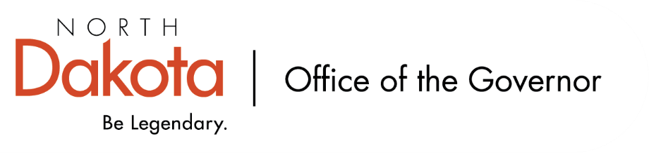

North Dakota Children’s Cabinet – HB1556 Subcommittee
Friday, November 14, 2025
8 – 9:30 am, Central Time
Microsoft Teams

Members in Attendance:
- Senator Kathy Hogan
- Director Colby Braun, ND DOCR
- Ms. Rhonda Allery, Mountain Lakes Human Service Zone Director
- Dr. Dan Cramer, NDHHS Behavioral Health Direct Services
- Ms. Kari Davis, ND DOCR, Juvenile Services Program Manager
- Ms. Cathy Federer, Director of Juvenile and Family Services, ND Court System
- Mr. Shawn Huss, Wilmac Special Education Unit
- Ms. Nicole Leitner, Director of Juvenile Court Service, Unit 2
- Ms. Mary McCarvel-O'Connor, NDDPI
- Ms. Janell Regimbal, Insight to Solutions
- Ms. Pamela Sagness, NDHHS Behavioral Health
- Ms. Veronica Zietz, Protection and Advocacy Project

Members Absent:
- Senator Michelle Axtman

Other Attendees:
- Mr. Jason Callahan, Forum for Youth Investment
- Mr. Aaron Benson, DD Program Administrator – Region 5
- Ms. Lynn Flieth, Director, RSR Human Service Zone Director
- Ms. Maria Neset, Governor's Office
- Ms. Mary Christy, Governor's Office

Roll Call / Approval of Agenda
Ms. Regimbal moved to approve the minutes from the North Dakota Children’s Cabinet HB1556 Subcommittee on September 5, 2025 with updates; Director Braun seconded. Motion approved.

Director Braun moved to approve the minutes from the North Dakota Children’s Cabinet HB1556 Subcommittee on October 10, 2025; Ms. Ferderer seconded. Motion approved.
Overview of Children’s Cabinet status and activities
Discussion on three subcommittees under the Children’s Cabinet. HB1556 came from legislation during the 2025 session; work to define children with complex needs and establish a system of care across North Dakota.

Strategic Planning will focus on the vision for the Cabinet that all children are prepared and successful, equipped with skills, knowledge and resilience to thrive in an ever-changing world. Looking to develop a scorecard that is focused on data and empowering youth centric decisions.

Early Childhood will focus on early childhood, and The Hunt Institute will be joining to provide assistance (similar to FYI joining this and Strategic Planning subcommittees). Will be looking at data for early childhood; what do we have currently and what are we lacking; how can we improve systems / programs / processes for our youth.

Discussion on NDHHS Youth Focus Group Study
- 2025.11.14 - HB1556 Subcommittee - HHS Youth Services Focus Groups
- 2025.11.14 - HB1556 Subcommittee - HHS Youth Services Focus Groups Moderator Comments

Discussion around study. NDHHS contracted to do this study primarily focused on schools and law enforcement related incidents at schools. The study was a surprise and Chair Hogan felt it was important to bring to the subcommittee for the work that is being done by and a data point for the group.

The report brought to light similar issues / concerns as were discussed during the July retreat including: system and service gaps, cross system collaboration, parents in crisis / family capacity, eligibility and accessibility, and workforce challenges.

Discussion on potential structure / timelines for regional meetings
- Who are the right people to invite?
- Who should facilitate / moderate?
- How to report the meeting outcomes?

North Dakota is broken down into eight Regional Human Service Centers. Hope is to have focus group in each of the eight regions with two meeting before the next Subcommittee meeting in December and the other six by mid-January 2026. Focus will be on children with unmet needs, serious behavioral health issues.

Discussion on regions / areas that may be overlooked, how do we not double up on work already being done, how do we capture work being done that would be helpful for the work the subcommittee is hoping to focus on. Importance of getting rural feedback in addition to the larger communities within each region.

Discussion regarding the right people to invite. Suggestions include: Special Ed, Child Welfare, Behavioral Health Clinics, Juvenile Courts, Human Service Zone Director, Tribal, parent advocate, Private Service Provider, Advocacy Group. Systems of Care grant recipients may be good to consider engaging (Devils Lake and Bismarck). Will move forward with Devils Lake and Grand Forks.

Mr. Callahan and Senator Hogan will work on building out a structured agenda for facilitating the regional meetings; start with two, adjust as needed for the following six. Will ask individuals to bring their most complex need case without identifying the child(ren).

Approaches to regional data collection without personally identifiable information
Consensus among group of being sensitive to not personally identifying the child(ren) or families.

Discussion around definition of complex needs. Will start with APHSA definition and build from there. “…youth whose needs span across multiple systems, requiring intensive coordination and support. These youth often have extensive trauma histories, substance use, severe behavior and emotional issues, cooccurring disorders, and developmental disabilities.”

Next Steps and Adjourn
- Subcommittee members can forward sample cases / case descriptions to Senator Hogan for consideration as part of the regional meeting agenda
- Next meeting scheduled for Friday, December 12, 2025 at 8 am via Teams

