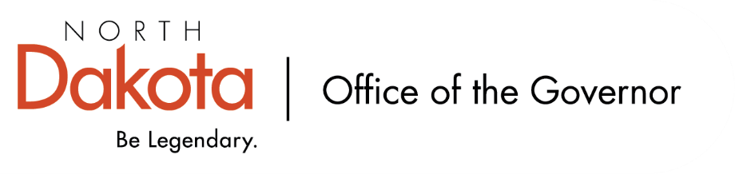

North Dakota Children’s Cabinet –
HB1556 Subcommittee
11.14.2025 -- 8:00-9:30 am
Microsoft Teams
Join the meeting now
Meeting ID: 212 640 901 463 3
Passcode: Nw9s45La

Vision: The North Dakota Children’s Cabinet ensures that all children are prepared and successful, equipped with the skills, knowledge, and resilience to thrive in an every-changing world.

Mission: The North Dakota Children’s Cabinet collaborates to elevate what works and drive towards a seamless network of services and supports that meet the needs of every child and family.

8:00-8:10 Welcome, Roll Call/Approval of the Agenda, Introductions, Review and Approve minutes from 9.5.2025 (with updates) and 10.10.2025  2025.09.05 - HB 1556 - Draft Final Minutes with 2025.10 updates.docx  2025.10.10 - HB 1556 - Draft Final Minutes.docx | Senator Hogan/Jason
8:10-8:20 Overview of Children’s Cabinet status and activities | Senator Hogan/Jason
8:20-8:30 Discussion on NDHHS Youth Focus Group Study  2025.11.14 - HB1556 Subcommittee - HHS Youth Services Focus Groups.pdf  2025.11.14 - HB1556 Subcommittee - HHS Youth Services Focus Groups Moderator Comments.docx | Senator Hogan/Jason
8:30-9:10 Discussion of potential structure / timelines for regional meetings  - Who are the right people to invite?  - Who should facilitate / moderate?  - How to report the meeting outcomes? | Senator Hogan/Jason
9:10-9:25 Approaches to regional data collection without personally identifiable information | Senator Hogan/Jason
9:25-9:30 Next Steps & Adjourn | Senator Hogan/Jason
Next Scheduled Subcommittee Meeting
Friday, December 12 at 8:00 AM

