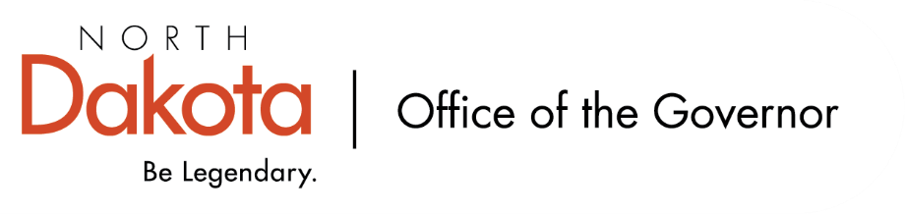

North Dakota Children’s Cabinet
Tuesday, November 18, 2025
4:00 p.m., Central Time
Microsoft Teams

Members in Attendance:
- Lieutenant Governor Michelle Strinden
- Senator Michelle Axtman
- Commissioner Pat Traynor
- Justice Lisa McEvers
- Senator Kathy Hogan
- Representative Jayme Davis
- Representative Brandy Pyle
- Ms. Daniell Breland
- Mr. Shawn Huss
- Mr. Russ Riehl
- Ms. Veronica Zietz

Members Absent:
- Superintendent Kirsten Baesler
- Ms. Kimberly Jacobson
- Ms. Janell Regimbal

Other Attendees:
- Mr. Jason Callahan
- Ms. Maria Neset
- Ms. Mary Christy

Ms. Zietz moved to approve the North Dakota Children’s Cabinet minutes from October 21, 2025. Senator Hogan seconded. The motion to approve the minutes carried.

Strategic Planning Subcommittee Share Out
Moving forward with child wellbeing metrics within the four main domains: education, economic, safety and health, and family and community. A survey has been sent out to the subcommittee to begin to rank items that they feel are most important and will bring to the full Children’s Cabinet.

Starting to look at who the stakeholders should be that we engage to help move the indicators forward.

Have received a final version of the operations manual. Subcommittee will review and bring to the full Children’s Cabinet once it is in final draft status.

If anyone is aware of additional data sets, especially in the area of early childhood, please include that in the shared spreadsheet or email directly to Mr. Callahan and Ms. Neset.

Next Meeting – November 25, 2025 from 4 – 5 pm.

Early Childhood Subcommittee Share Out
At the last meeting, looked at around 20 indicators one by one and visited if it was an indicator they felt was something the subcommittee or Children’s Cabinet should focus on. Narrowed down the list and will be working with The Hunt Institute to dive into the early childhood environment.

Lt. Governor Strinden, Senator Axtman, and Ms. Neset were able to travel to Williston to learn more about schools participating in the BARR program as well as Head Start and Best in Class. Pre-K programs are working together as a community; will be expanding and centralizing these programs. The community sees / finds value in the early childhood / pre-k programming and stepping up to help meet the needs.

Question on Rural Health Transformation Program and if any dollars could go towards 0-5 programs. Commissioner Traynor will look into and share with the group if there may be an opportunity to support / expand pre-k programs.

Next meeting – December 17, 2025 from 11 am – 12 pm.

HB1556 Subcommittee Share Out
NDHHS shared a Youth Focus Group study that focused on law enforcement and special education school staff. Working to see how it connects with the work the subcommittee is focusing on.

Adopted a preliminary definition of the children they are focusing on. American Public Human Services Association definition will be the base “Youth whose needs span across multiple systems, requiring intensive coordination and support. These youth often have extensive trauma histories, substance use, severe behavioral and emotional issues, co-occurring disorders, and developmental disabilities.”

Planning small regional meetings to start looking at what is happening in our communities, what is working well, and what unmet needs are out there. Will start with two pilot meetings and adjust as appropriate for the other six meetings; planning for two pilot meetings to occur before December subcommittee meeting.

Next meeting – December 12, 2025 from 8 – 9:30 am.

In-Person Retreat – March 9, 2026
Will be holding an in-person retreat on Monday, March 9, 2026 in Fargo. More details and information will be coming as plans get confirmed. Will work to get a virtual option for members who are unavailable to join in person.

Closing remarks
- Next meeting – Tuesday, December 16 from 3:45 – 5 pm.

