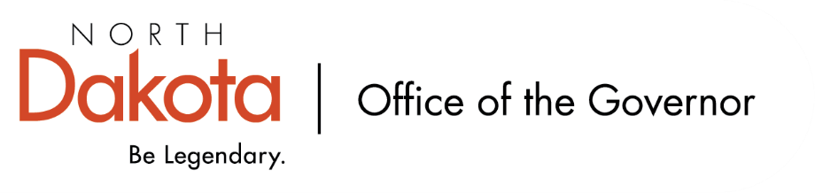

North Dakota Children’s Cabinet – Strategic Planning Subcommittee
Monday, November 25, 2025
4 p.m., Central Time
Microsoft Teams

Members in Attendance:
- Ms. Kimberly Jacobson
- Representative Brandy Pyle
- Ms. Daniell Breland
- Mr. Russ Riehl

Members Absent:
- Justice Lisa McEvers

Other Attendees:
- Mr. Jason Callahan
- Ms. Maria Neset
- Ms. Mary Christy
- Ms. Missy Baranko
- Ms. Allison Mahoney

Mr. Riehl moved to approve the minutes from the North Dakota Children’s Cabinet Strategic Planning Subcommittee meeting on November 10, 2025; Ms. Jacobson seconded. Motion approved.

Discuss “draft” thematic scorecard definitions
Reviewed Indiana Graduates Prepared to Succeed dashboard; good example to consider as we continue our work. Group appreciates the conciseness, but also thoroughness, user friendly, easy to read / understand.

Draft definitions discussed amongst the group. Want to start framing why we think these five areas are important in terms of the bigger picture of the Children’s Cabinet and child wellbeing. Definitions are pared down and direct while balancing different thoughts on what each area is (which is included in the broader description of each indicator; more in depth).

Proposal to pull early years from education and add it as its own component; agreement from the group to move forward with adding early years as its own.

Ms. Christy will send out survey to gather the subcommittee’s input on the concise definitions and broad descriptions of the five areas. Will take feedback and update the as appropriate to be able to present to the Children’s Cabinet.

Discuss indicator survey results
Consensus among subcommittee with ranking of indicators; nothing was surprising.

Discussion on items that are not listed – screen time, recess play, access to services, extracurricular activities for example – where we can look to see if we have data available either nationally or statewide.

Discussion on indicators leaning more towards parent centric versus child centric – health and safety, economic, family and community indicators. Youth unemployment v. parent unemployment, how do we capture data points for 0-5 year olds in the economic indicators / employment.

Similar discussion with heavy focus on education data sets and how do we incorporate the entire wellbeing of the child, which includes more than education.

Children’s Cabinet Ops-Manual Review
Subcommittee asked to review draft ops-manual. Intention is that the manual will be a public document, but more internal facing for the Children’s Cabinet.

Closing remarks
- Next Children’s Cabinet Strategic Plan Subcommittee meeting: Monday, December 8 @ 4pm on Microsoft Teams

