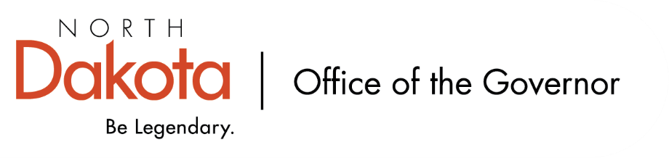

North Dakota Children’s Cabinet – Strategic Planning Subcommittee
Monday, December 8, 2025
4 p.m., Central Time
Microsoft Teams

Members in Attendance:
- Ms. Kimberly Jacobson
- Justice Lisa McEvers
- Representative Brandy Pyle
- Ms. Daniell Breland
- Mr. Russ Riehl

Members Absent:

Other Attendees:
- Mr. Jason Callahan
- Ms. Mary Christy
- Ms. Missi Baranko
- Ms. Allison Mahoney

Mr. Riehl moved to approve the minutes from the North Dakota Children’s Cabinet Strategic Planning Subcommittee meeting on November 25, 2025; Representative Pyle seconded. Motion approved.

Children’s Cabinet Ops-Manual Review
Justice McEvers recommends moving the Ops-Manual to full Children’s Cabinet for review and approval; Mr. Riehl seconded. Recommendation approved.

Indicator Definition and Broad Survey Feedback Follow-Up
Intention is for our indicators to tell a data story that is accessible, easy to read, and moves the work forward. Five indicators include: Education, Economic Stability, Family and Community, Health and Safety, and The Early Years. Want to remain child-centered and family-focused; transparent; nimble; want the story we tell to impact and make positive changes.

Recommended including additional text similar to “…we see The Early Years as 0-5”; spell it out more in the beginning of the description. Discussion on if it gets tied into the state definition of what early childhood is. Could look to Early Childhood Subcommittee as well to help avoid mixed messages.

Additional discussion surrounding the other four domains. Consensus among the subcommittee that the descriptions were good with minor tweaks.

Indicators Scorecard Visuals
The Early Years – elevate indicators that the group is focused on prioritizing from survey subcommittee commented on. Included infant mortality rate, WIC or SNAP participation, quality early childhood education, number of childcare providers.

Family and Community – elevate indicators focused on access to quality early childhood, chronic absenteeism, family economic stability, extracurricular involvement.

Health and Safety – elevate indicators focused on school discipline, screen time, mental health, access to school based behavioral health services.

Education – elevate indicators focused on 3rd grade literacy, kindergarten readiness, choice ready, post-secondary enrollment.

Economic Stability – elevate indicators focused on homeless youth, unemployment rate of parents, children living in poverty (0-17), youth employment / opportunity youth.

Discussion on other potential missed indicators, who our target audience is / will be, timeframe of indicators. Consensus that we’re on the right track; there is some refining to be done to make sure we have the right balance.

Closing remarks
- Next Children’s Cabinet Strategic Plan Subcommittee meeting: Tuesday, December 23 @ 4pm on Microsoft Teams

