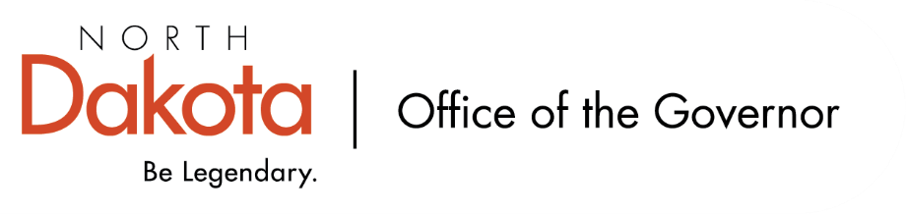

North Dakota Children’s Cabinet – HB1556 Subcommittee
Friday, December 12, 2025
8 – 9:30 am, Central Time
Microsoft Teams

Members in Attendance:
- Senator Kathy Hogan
- Director Colby Braun, ND DOCR
- Ms. Rhonda Allery, Mountain Lakes Human Service Zone Director
- Dr. Dan Cramer, NDHHS Behavioral Health Direct Services
- Ms. Kari Davis, ND DOCR, Juvenile Services Program Manager
- Ms. Cathy Federer, Director of Juvenile and Family Services, ND Court System
- Mr. Shawn Huss, Wilmac Special Education Unit
- Ms. Nicole Leitner, Director of Juvenile Court Service, Unit 2
- Ms. Mary McCarvel-O'Connor, NDDPI
- Ms. Janell Regimbal, Insight to Solutions
- Ms. Pamela Sagness, NDHHS Behavioral Health
- Ms. Veronica Zietz, Protection and Advocacy Project

Members Absent:

Other Attendees:
- Mr. Jason Callahan
- Mr. Travis Finck
- Ms. Lynn Flieth
- Ms. Mary Christy

Roll Call / Approval of Agenda
Ms. Leitner moved to approve the minutes from the North Dakota Children’s Cabinet HB1556 Subcommittee on November 14, 2025; Ms. Regimbal seconded. Motion approved.

Overview of Children’s Cabinet status and activities; Child Wellbeing Scorecard Examples
Strategic Planning Subcommittee building out proposed Child Wellbeing Scorecard to encompass all youth and bring in the work being done by the Early Childhood and HB1556 Subcommittees. Progress has been made on firming up the five domains (Education, Economic Stability, Family and Community, Health and Safety, and The Early Years) and indicators to include in each. Intention is for scorecard to build out a narrative for policy makers and practitioners; understanding the audience will reach beyond those two groups. If members of this subcommittee have suggested metrics for the wellbeing scorecard, send to Mr. Callahan

Regional Meetings Update
Have planned for two regional meetings by the end of December. Region 3, Devils Lake, has a Systems of Care project that is helpful with who to consider having join the meeting to provide their experience / feedback on cross-systems and complex youth case(s).

First meeting will be held on Monday, December 15th in Grand Forks. Devils Lake will be on Thursday, December 18th. There were 12 community participants and the group has decided to continue to meet monthly to discuss cross systems issues.

If anyone is aware of someone who would be a good facilitator for the remaining six regions, please let Senator Hogan know.

Discussion of other related groups
There are several related working groups focusing on youth and juvenile services and education such as the Juvenile Justice Committee, Diversion Work Group, Level D Work Group; ask that the group please let Senator Hogan and Mr. Callahan know if they are aware of other working groups or reports being conducted in this area.

Next Steps and Adjourn
- Next meeting scheduled for Friday, January 9, 2026 at 8 am via Teams

