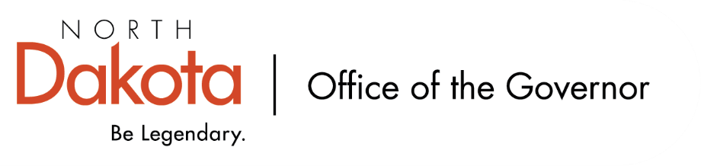

North Dakota Children’s Cabinet – Early Childhood Subcommittee
Wednesday, December 17, 2025
11 a.m., Central Time
Microsoft Teams

Members in Attendance:
- Lieutenant Governor Michelle Strinden
- Senator Michelle Axtman
- Commissioner Pat Traynor, North Dakota Department of Health and Human Services
- Ms. Keely Ihry, South East Education Cooperative
- Ms. Amanda Peterson, North Dakota Department of Public Instruction on behalf of Superintendent Levi Bachmeier

Members Absent:
- Representative Jayme Davis

Other Attendees:
- Ms. Missi Baranko
- Mr. Jason Callahan
- Ms. Kelly Eppley, The Hunt Institute
- Ms. Michelle Fockler, The Hunt Institute
- Ms. Pritha Gopalan, The Hunt Institute
- Ms. Kay Larson, Early Childhood Director, North Dakota Department of Health and Human Services
- Ms. Allison Mahoney
- Ms. Maria Neset
- Ms. Mary Christy

Ms. Ihry moved to approve the minutes from the North Dakota Children’s Cabinet Early Childhood Subcommittee meeting on November 12, 2025. Ms. Peterson seconded. Motion approved.

Introduction to The Hunt Institute Team
Ms. Eppley, Ms. Fockler, and Ms. Gopalan will be joining the Subcommittee as external experts. The Hunt Institute is acting in a supportive role to help the Subcommittee focus on early learners in North Dakota in terms of research, technical expertise, and learning opportunities. Ms. Gopalan, Ms. Fockler, and Ms. Eppley have an extensive history in prenatal to post-secondary. The Hunt Institute has previously worked with North Dakota through annual retreat for state legislators to learn about issues across the continuum.

Subcommittee members took turns introducing themselves and their roles.

Subcommittee Check In and Adjourn
- Next Children’s Cabinet Early Childhood Subcommittee meeting: Tuesday, January 14, 2026 @ 2-3 pm on Microsoft Teams

