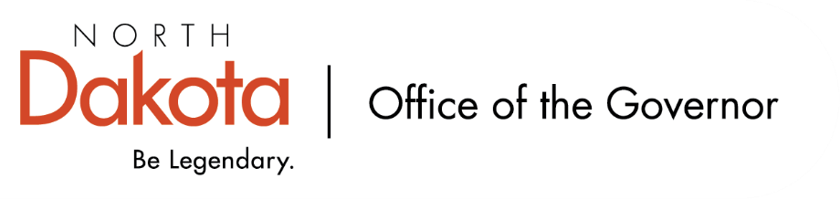

North Dakota Children’s Cabinet – HB1556 Subcommittee
Friday, January 9, 2026
8 – 9:30 am, Central Time
Microsoft Teams

Members in Attendance:
- Senator Kathy Hogan
- Director Colby Braun, ND DOCR
- Ms. Rhonda Allery, Mountain Lakes Human Service Zone Director
- Dr. Dan Cramer, NDHHS Behavioral Health Direct Services
- Ms. Kari Davis, ND DOCR, Juvenile Services Program Manager
- Ms. Cathy Federer, Director of Juvenile and Family Services, ND Court System
- Mr. Shawn Huss, Wilmac Special Education Unit
- Ms. Nicole Leitner, Director of Juvenile Court Service, Unit 2
- Ms. Mary McCarvel-O'Connor, NDDPI
- Ms. Janell Regimbal, Insight to Solutions
- Ms. Pamela Sagness, NDHHS Behavioral Health
- Ms. Veronica Zietz, Protection and Advocacy Project

Members Absent:

Other Attendees:
- Mr. Aaron Benson
- Mr. Jason Callahan
- Ms. Mary Christy
- Ms. Lynn Flieth
- Mr. Tim Gienger
- Ms. Maria Neset
- Mr. Luke Schaefer
- Ms. Michelle Woodcock

Roll Call / Approval of Agenda
Mx. Zietz moved to approve the minutes from the North Dakota Children’s Cabinet HB1556 Subcommittee on December 12, 2025; Director Braun seconded. Motion approved.

Overview of Children’s Cabinet status and activities
Strategic Planning Subcommittee looking at child wellbeing and building out a scorecard that potentially would turn into a dashboard for stakeholders to reference and refer to. Working to build out additional stakeholder engagement on indicators, gain additional feedback.

The Hunt Institute will be joining the Early Childhood Subcommittee to help strategically focus on the research and work being done.

If any of the subcommittee members are aware of publicly available datasets, please send them to Ms. Neset and Mr. Callahan. Working to compile as comprehensive of list as possible to help define child wellbeing in North Dakota and the elevate the work being done by the Children’s Cabinet.

Regional Meetings Update
Trying to track other work groups in our regions that are working on / looking at topics the HB1556 Subcommittee is focusing on. If there are groups the subcommittee is aware of, please let Senator Hogan know as they will work to compile a list of resources.

Pilot group in Grand Forks held their regional meeting back in December. Local facilitators identified key local leaders to identify participants to attend and looking to continue this with the additional 7 regions. The in-person meeting was incredibly beneficial and insightful; empowering local voices on the issues they are seeing and engaging on state policy. Grand Forks group continues to meet on their own to continue the conversation.

Devils Lake will take place on Monday, January 12 and Bismarck on Wednesday, January 14. Jamestown will be held later in January. Hoping by the end of February we will have held a regional meeting in all 8 regions in North Dakota.

Residential Services for Children and Adolescence with Intellectual Disabilities
Discussion on report provided on LSTC referrals and admissions. Clarification that data includes children in residential treatment. Question on if data includes life skills and training center? If not, would there be a data set that includes these numbers?

Discussion regarding hoteling
There are children with significant unmet needs in at least two regions and people are asking for help. If there are children being hoteled without appropriate placements or children with complex needs falling through the cracks, Senator Hogan asked for the subcommittee members to let her and Mr. Callahan know.

Discussion regarding 2112 and how that relates to the work being focused on in the subcommittee. Any information on noneligibles that are not developmentally disabled that are at life skills? How are referrals made? How do they staff cases? Senator Hogan and Mr. Benson can follow up on reporting being done and if more regular reports can be shared.

Ruth Meiers receiving private referrals from private healthcare facilities; they have done substantial changes as it relates to behavioral health, helping parents navigate to avoid public custody, and available to provide targeted services to families.

Next Steps and Adjourn
- Next meeting scheduled for Friday, February 13, 2026 at 8 am via Teams

