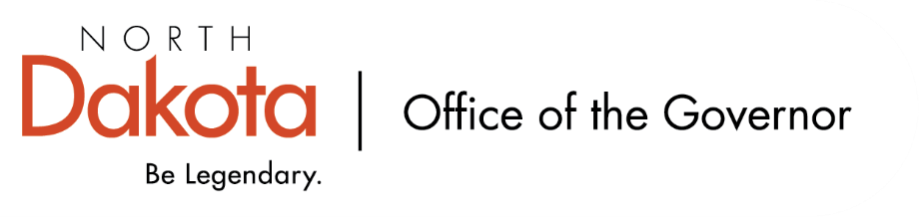
North Dakota Children’s Cabinet
Early Childhood Subcommittee
9.22.2025 – 3:45 – 5:15 pm
Microsoft Teams
Join the meeting now
Meeting ID: 235 917 369 735 6
Passcode: u72gK6HN

3:45-3:50 Roll Call & Approval of Meeting Minutes  2025.07.28 - Early Childhood SubCommittee Meeting Notes - FINAL.docx | Sen. Axtman &  Lt. Governor Strinden
3:50-4:10 Early Childhood Presentation from HHS  - Program Overview  - Current State  - Data and Program Metrics | Jessica Thomassen & Kay Larson
4:10-4:20 Debrief Discussion
4:20-4:40 Child Care Presentation from GA Group  GA Group Presentation Governors Childrens Cabinet 092225.pptx | Amy Cleary
4:40-4:50 Debrief Discussion
4:50-5:00 Upcoming Events  - Overview of the interim legislative studies  - Site visit details | Sen. Axtman & Lt. Governor Strinden
5:00 Adjourn
Next Scheduled Meeting
October 8, 2025 -- 2 – 3 pm CST via Teams

